Mathematics

Power Standard 8:12

Summative Test

Name _______________________________________________ Hour _________

1. 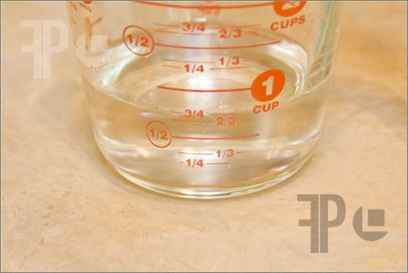 The precision of the measuring cup is:
2. 1 cup
3. $\frac{1}{4}$ cup
4. $\frac{1}{2}$ cup
5. $\frac{3}{4}$ cup
6. Determine the number of significant digits in the following number: 301.01

Number of significant digits: _______________

1. Compute using significant digits. Show work.

What is the area of a rectangle with a length of 17.25 mm and a width of 5.065 mm?

Area = ______________________________