**MPS8:11 Summative Scoring Guide**

|  |  |  |  |  |  |  |  |
| --- | --- | --- | --- | --- | --- | --- | --- |
| ITEM# | SR | CR | PT | GLE | OBJ | EXP | DESCRIPTOR |
| 1. | B |  | 1 | D2A |  |  | Measures of Center |

|  |  |  |  |  |  |  |  |
| --- | --- | --- | --- | --- | --- | --- | --- |
| ITEM# | SR | CR | PT | GLE | OBJ | EXP | DESCRIPTOR |
| 2. | A |  | 1 | D2A |  |  | Measures of Center |

|  |  |  |  |  |  |  |  |
| --- | --- | --- | --- | --- | --- | --- | --- |
| ITEM# | SR | CR | PT | GLE | OBJ | EXP | DESCRIPTOR |
| 3. | B |  | 1 | D2A |  |  | Range/Interquartile Range |

|  |  |  |  |  |  |  |  |
| --- | --- | --- | --- | --- | --- | --- | --- |
| ITEM# | SR | CR | PT | GLE | OBJ | EXP | DESCRIPTOR |
| 4. |  | X | 2 | D1C |  |  | Graphical Representation |

Answer: Example answer: Make a line graph for the following

information:

Number of Common Dolphins seen in Santa Barbara Channel from 1996-2001:

1996: 1900

1997: 7600

1998: 4400

1999: 6100

2000: 4800

2001: 7800

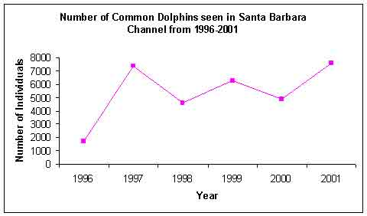

2 points: Exemplary response; line graph titled, x and y axis labeled

correctly, information graphed correctly, explanation of

usefulness correct.

1 point: 2-3 of the above elements are correct.

0 points: none of the above elements are correct.

|  |  |  |  |  |  |  |  |
| --- | --- | --- | --- | --- | --- | --- | --- |
| ITEM# | SR | CR | PT | GLE | OBJ | EXP | DESCRIPTOR |
| 5. |  | X | 2 | D2B |  |  | Misleading Representation of Data |

Answer: Example answer: Make a bar graph and don’t start the y-axis

counting at “0”, make a bar graph and don’t use consistent

intervals, make a picto-graph and use distorted pictures.

2 points: Exemplary response; 2 correct methods explained.

1 point: 1 correct method explained.

0 points: No correct method explained.

|  |  |  |  |  |  |  |  |
| --- | --- | --- | --- | --- | --- | --- | --- |
| ITEM# | SR | CR | PT | GLE | OBJ | EXP | DESCRIPTOR |
| 6. |  | X | 2 | D2A |  |  | Measures of Center |

Answer: Example answer: 5,6,7,8,9,10,10

2 points: Exemplary response; both mode and median are correct for set of data given.

1 point: Either mode or medians is correct, but not both.

0 points: Neither mode or median is correct.