**MPS8:11 Pre-Formative Scoring Guide**

|  |  |  |  |  |  |  |  |
| --- | --- | --- | --- | --- | --- | --- | --- |
| ITEM# | SR | CR | PT | GLE | OBJ | EXP | DESCRIPTOR |
| 1. | D |  | 1 | D2A |  |  | Measures of Center |

|  |  |  |  |  |  |  |  |
| --- | --- | --- | --- | --- | --- | --- | --- |
| ITEM# | SR | CR | PT | GLE | OBJ | EXP | DESCRIPTOR |
| 2. | B |  | 1 | D2A |  |  | Measures of Center |

|  |  |  |  |  |  |  |  |
| --- | --- | --- | --- | --- | --- | --- | --- |
| ITEM# | SR | CR | PT | GLE | OBJ | EXP | DESCRIPTOR |
| 3. | A |  | 1 | D2A |  |  | Range/Interquartile Range |

|  |  |  |  |  |  |  |  |
| --- | --- | --- | --- | --- | --- | --- | --- |
| ITEM# | SR | CR | PT | GLE | OBJ | EXP | DESCRIPTOR |
| 4. |  | X | 2 | D1C |  |  | Graphical Representation |

Answer: Example answer:

Use the following test scores to create a histogram: 98,67,88,87,95,73,74,89,86,99,67,70,72,73,69,94,86,96,94

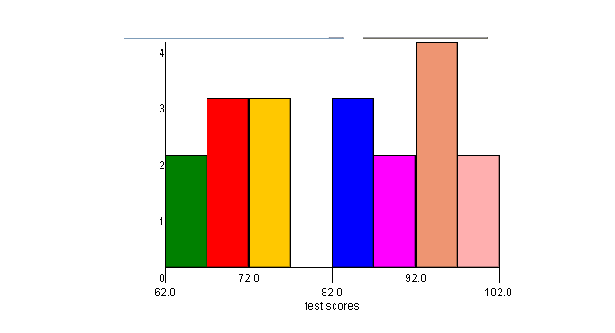

2 points: Exemplary response; histogram titled, correct intervals (no gaps or

overlaps, intervals are consistent, correct frequency on y-axis),

explanation of usefulness correct.

1 point: 2-3 of the above elements are correct.

0 points: none of the above elements are correct.

|  |  |  |  |  |  |  |  |
| --- | --- | --- | --- | --- | --- | --- | --- |
| ITEM# | SR | CR | PT | GLE | OBJ | EXP | DESCRIPTOR |
| 5. |  | X | 2 | D2B |  |  | Misleading Representations of Data |

Answer: Example answer: Make a bar graph and don’t start the y-axis

counting at “0”, make a bar graph and don’t use consistent

intervals, make a picto-graph and use distorted pictures.

2 points: Exemplary response; 2 correct methods explained.

1 point: 1 correct method explained.

0 points: No correct method explained.

|  |  |  |  |  |  |  |  |
| --- | --- | --- | --- | --- | --- | --- | --- |
| ITEM# | SR | CR | PT | GLE | OBJ | EXP | DESCRIPTOR |
| 6. |  | X | 2 | D2A |  |  | Measures of Center |

Answer: Example answer: 1,2,3,4,5,6,6,8,8,8,8

2 points: Exemplary response; both mode and median are correct for set of

data given.

1 point: Either mode or medians is correct, but not both.

0 points: Neither mode or median is correct.