**MPS8:11 Post-Formative Scoring Guide**

|  |  |  |  |  |  |  |  |
| --- | --- | --- | --- | --- | --- | --- | --- |
| ITEM# | SR | CR | PT | GLE | OBJ | EXP | DESCRIPTOR |
| 1. | B |  | 1 | D2A |  |  | Measures of Center |

|  |  |  |  |  |  |  |  |
| --- | --- | --- | --- | --- | --- | --- | --- |
| ITEM# | SR | CR | PT | GLE | OBJ | EXP | DESCRIPTOR |
| 2. | A |  | 1 | D2A |  |  | Measures of Center |

|  |  |  |  |  |  |  |  |
| --- | --- | --- | --- | --- | --- | --- | --- |
| ITEM# | SR | CR | PT | GLE | OBJ | EXP | DESCRIPTOR |
| 3. | C |  | 1 | D2A |  |  | Range/Interquartile Range |

|  |  |  |  |  |  |  |  |
| --- | --- | --- | --- | --- | --- | --- | --- |
| ITEM# | SR | CR | PT | GLE | OBJ | EXP | DESCRIPTOR |
| 4. |  | X | 2 | D1C |  |  | Graphical Representation |

Answer: Example answer: Use the following test scores to create a box-

and-whisker plot: 69,95,83,85,74,78,86,76,93,82,78,76,83,85,94,98,97,89,70,75

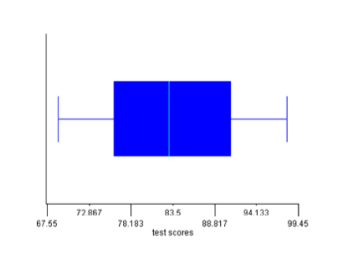

2 points: Exemplary response; box-and-whisker plot titled; lower extreme, lower quartile, median, upper quartile, upper extreme correct; explanation of usefulness correct.

1 point: 3-4 of the above elements are correct.

0 points: none of the above elements are correct.

|  |  |  |  |  |  |  |  |
| --- | --- | --- | --- | --- | --- | --- | --- |
| ITEM# | SR | CR | PT | GLE | OBJ | EXP | DESCRIPTOR |
| 5. |  | X | 2 | D2B |  |  | Misleading Representation of Data |

Answer: Example answer: Make a bar graph and don’t start the y-axis

counting at “0”, make a bar graph and don’t use consistent

intervals, make a picto-graph and use distorted pictures.

2 points: Exemplary response; 2 correct methods explained.

1 point: 1 correct method explained.

0 points: No correct method explained.

|  |  |  |  |  |  |  |  |
| --- | --- | --- | --- | --- | --- | --- | --- |
| ITEM# | SR | CR | PT | GLE | OBJ | EXP | DESCRIPTOR |
| 6. |  | X | 2 | D2A |  |  | Measures of Center |

Answer: Example answer: 0,0,1,1,2,2,2,4,4,4,4

2 points: Exemplary response; both mode and median are correct for set of data given.

1 point: Either mode or medians is correct, but not both.

0 points: Neither mode or median is correct.