Mathematics

Power Standard 8:10

Summative Test

Name ________________________________________________ Hour ________

1. Which set of ordered pairs is a solution to y=5x+3?

a. ( 1,20 ), ( 2,25 ), ( 3,30 )

b. ( 1,53 ), ( 2,23 ), ( 3,3 )

c. ( 0,3 ), ( 5,28 ), ( 10,53 )

d. ( -1,8 ), ( -2,13 ), ( -3,18 )

1. Write a function rule and make a t-bar of values. Graph your function rule.
2. Use the following set of ordered pairs to write a function rule: (0,25), (1,35), (2, 45). Illustrate your rule with a word problem.
3. Determine the next three terms of the following sequence.

8,13,18,…

Write a function rule for the sequence and use it to find the 15th term.

1. Does the following set of ordered pairs represent a linear pattern? Explain.

(0,-1), (1,3), (2,7), (3,11)

1. Describe the following situation: The size of square flooring tiles and the number of tiles required to cover the floor.
2. positive relationship
3. no relationship
4. negative relationship
5. neutral relationship
6. Given: y = $\frac{1}{2}$ x -3, which of the following is true?
7. m = 3, b = $\frac{1}{2}$
8. m = $\frac{1}{2}$, b = -3
9. m = $\frac{1}{2}$, b = 3
10. m = 1, b = 2
11. Solve: 2w – 6 = 5w + 15
12. w = -7
13. w = 3
14. w = 16
15. w = 7
16. Solve: 6 – 4x = 4x – 2
17. x = - $\frac{1}{2}$
18. x = 0
19. x = -1
20. x = 1
21. Identify the slope and y-intercept of the following:

Y= -3x+4

m=__________ b = _________

1. Given the following graph of a linear function, write the equation of the line in slope-intercept form.

Equation: ______________________

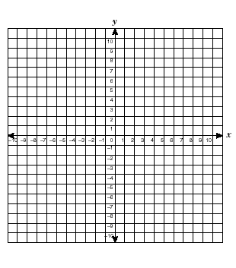

1. Graph y= -($\frac{1}{2}$)x + 2. Identify the slope and y-intercept.

m = _________ b = ___________



10. Use the following t-bar to make a scatter plot. Use a line of fit to predict the

number of words read per minute. Explain how you arrived at your

prediction.



Minutes Words Read

2 115

3 175

4 200

5 250

6 280

1. Use the following table to answer the following question. What was the rate of change between 1:10 and 1:20? Explain your answer.

Time 1:00 1:05 1:10 1:20

Envelopes Stuffed 15 25 40 70