Mathematics

Power Standard 8:10

Pre-Formative Test

Name _________________________________________________ Hour _______

1. Which set of ordered pairs is a solution to y=4x+2?

a. ( 1,6 ), ( 2,10 ), ( 3,16 )

b. ( 0,6 ), ( 1,6 ), (2,10 )

c. ( 0,0 ), ( 1,12 ), ( 2,16 )

d. ( 0,2 ), (1,6 ), ( 2,10 )

1. Write a function rule and make a t-bar of values. Graph your function rule.
2. Use the following set of ordered pairs to write a function rule: (0,5), (1,8), (2,11). Illustrate your rule with a word problem.
3. Determine the next three terms of the following sequence?

11, 20, 29, …

Write a function rule for the sequence and use it to find the 20th term.

1. Does the following chart represent a linear pattern? Explain.

X Y

1. 1
2. 3
3. 5
4. 7
5. Describe the following situation: As the temperature outside goes

up, the air conditioning bill goes up.

A. positive relationship

B. no relationship

C. negative relationship

D. neutral relationship

1. Identify the slope and y-intercept of the following:

Y=($\frac{1}{2}$)x+6

M=___________ b=__________

1. Given the following graph of a linear function. Write the equation of the line.

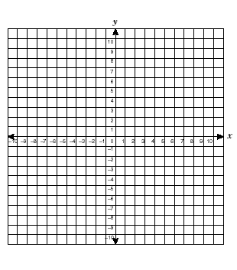

1. Graph y = ($\frac{3}{2}$) x-4. Identify the slope and y-intercept.

M=___________ b=_______________

1. Use the following t-bar to make a scatter plot. Use a line of fit to predict the shoe size of a 6’5” man.

Ht. in Inches Shoe Size

72 11

60 6.5

62 8

63 7.5

59 6.5

70 10

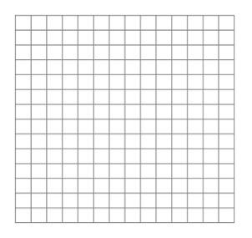

1. Use the following table to answer the following questions

Time 1:00 1:05 1:10 1:20

Envelopes stuffed 15 25 40 70

What was the rate of change between 1:00 and 1:05?