8-10 Pre-Test Scoring Guide

1. 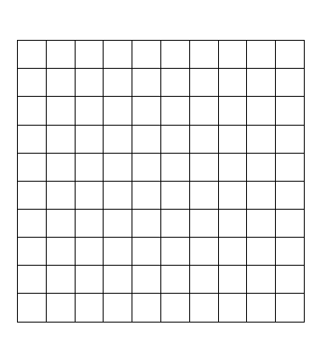 D
2. Example answer:

Y=2x+3 x y

1. 3
2. 5
3. 7
4. points: Exemplary response; both t-bar and graph are correct

1 point: t-bar or graph is correct but not both

0 points: neither t-bar nor graph is correct

1. y=3x+5 Example word problem: Membership to a video store costs $5.00. Each rental is $3.00. Write an equation to illustrate how much you will pay each time you rent from this store.

2 points: Exemplary response; both function rule and illustration are correct.

1 point: function rule or illustration is correct but not both

0 points: neither function rule nor illustration is correct.

1. Next three terms: 38, 47, 56

Y=9x+2

182

3 points: Exemplary response; next three terms are correct, function rule is correct, 20th term is correct

2 points: Two of the above elements are correct

1. point: One of the above elements are correct

0 points: None of the above elements are correct

1. Yes – all of the y values can be obtained by the rule: 2x+1

2 points: Exemplary response; both answer and reason are correct

1 point: Either answer or reason is correct but not both

0 points: Neither answer or reason is correct.

1. A
2. M= $\frac{1}{2}$, b=6

2 points: Exemplary response; correct slope and correct y-intercept

1 point: correct slope or correct y-intercept, but not both

0 point: neither slope nor y-intercept is correct

1. Y=($\frac{3}{2}$)x+2

2 points: Exemplary response; correct form, correct slope, and correct y-intercept

1 point: one of the above criteria correct

0 point: None of the above criteria correct

1. Graph y=($\frac{3}{2}$)x-4. Identify the slope and y-intercept.

M= $\frac{3}{2}$, b=-4

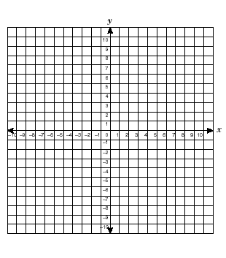

3 points: Exemplary response: graph is correct, correct slope, and correct y-intercept.

2 points: 2 of the above criteria correct

1 point: 1 of the above criteria correct

0 point: none of the above criteria correct.

1. Size 11.5



3 points: Exemplary response: graph is correct, line of fit is reasonable, prediction is reasonable

2 points: 2 of the above criteria is correct

1 point: 1 of the above criteria is correct

0 point: none of the above criteria is correct

1. 2 envelopes / minute

2 points: Exemplary response: correct answer and in reduced form

1 point: correct answer not in reduced form

0 point: incorrect answer