Mathematics

Power Standard 8:10

Post-Formative Test

Name ___________________________________________________ Hour _____

1. Which set of ordered pairs is a solution to y = -2x - 4?

a. ( 1,-6 ), ( 2,-8 ), ( 3,-10 )

b. ( 1,6 ), ( 2,4 ), ( 3,2 )

c. ( 1,-2 ), ( 2,0 ), ( 3,2 )

d. ( 0,0 ), ( 1,-2 ), ( 2,2 )

1. Write a function rule and make a t-bar of values. Graph your function rule.
2. Use the following set of ordered pairs to write a function rule: (0,1), (1,3), (2, 5). Illustrate your rule with a word problem.
3. Determine the next three terms of the following sequence? 4,2,0,…

Write a function rule for the sequence and use it to find the 20th term.

1. Does the following set of ordered pairs represent a linear pattern? Explain.

(1,1), (2,4), (3,9), (4,16)

1. Describe the following situation: As the temperature outside goes up, the heating bill goes down.
2. positive relationship
3. no relationship
4. negative relationship
5. neutral relationship
6. Identify the slope and y-intercept of the following:

y = **-** ($\frac{3}{4}$) x - 3

m=_______________ b=_____________________

1. Given the following graph of a linear function, write the equation of the line in slope-intercept form.

Equation: ___________________________

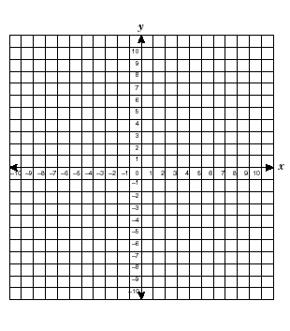

1. Graph y = **-**2x. Identify the slope and y-intercept.

m=____________________ b=________________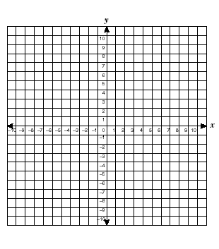

1. Use the following t-bar to make a scatter plot. Use a line of fit to predict the number of words that can be typed in 15 minutes. Explain how you arrived at your prediction.

Minutes Number of words

1. 45
2. 100
3. 130
4. 195
5. 245
6. 305



1. Use the table to answer the following question.

|  |  |  |  |  |
| --- | --- | --- | --- | --- |
| **Time** | 1:00 | 1:05 | 1:10 | 1:20 |
| **Presents Wrapped** | 15 | 25 | 40 | 70 |

What was the rate of change between 1:05 and 1:10? Explain.