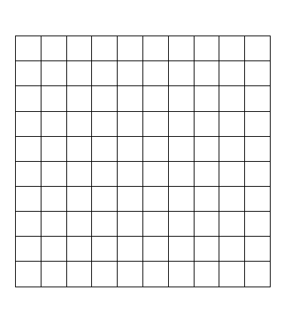8-10 Formative Scoring Guide

1. A
2. Example answer:

Y=4x-2 x y

1. -2
2. 2
3. 6
4. points: Exemplary response; both t-bar and graph are correct

1 point: t-bar or graph is correct but not both

0 points: neither t-bar nor graph is correct

1. y=2x+1 Example word problem: A plant is 1” tall when you plant it. It grows 2” a day. Write an equation to illustrate how tall it will be after “x” days.

2 points: Exemplary response; both function rule and illustration are correct.

1 point: function rule or illustration is correct but not both

0 points: neither function rule nor illustration is correct.

1. Next three terms: -2, -4, -6

Y=-2x+6

-34

3 points: Exemplary response; next three terms are correct, function rule is correct, 20th term is correct

1. points: Two of the above elements are correct

1 point: One of the above elements is correct

0 points: None of the above elements are correct

1. No – if you graph it, it is not in a line
2. points: Exemplary response; both answer and reason are correct

1 point: Either answer or reason is correct but not both

0 points: Neither answer or reason is correct

1. C
2. m = $-\frac{3}{4}$, b = -3

2 points: Exemplary response: correct slope and correct y-intercept

1 point: correct slope or correct y-intercept, but not both

0 point: neither slope nor y-intercept is correct

1. Answer: y = -x - 3

3 points: Exemplary response; correct form, correct slope and correct y-intercept

2 points: Two of the above

1 point: One of the above

0 point: None of the above criteria correct

1. Graph y = -2x. Identify the slope and y-intercept.

m = -2, b = 0

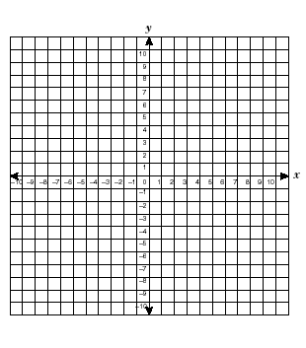

3 points: Exemplary response: Correct graph, correct slope, and correct y-intercept

2 points: 2 of the above criteria correct

1 point: 1 of the above criteria correct

0 point: None of the above criteria correct

1. 750 words; All reasonable answers should be accepted.



3 points: Exemplary response: correct graph, reasonable line of fit, and reasonable prediction

2 points: 2 of the above criteria correct

1 point: 1 of the above criteria correct

0 point: None of the above criteria correct

1. 3 Presents/minute

2 points: Exemplary response: correct answer in reduced form

1 point: Correct answer but not reduced

0 point: Incorrect answer