Mathematics

Power Standard 8:3

Summative Test

Name _______________________________________________ Hour _________

Show work for each problem

1. Solve x2=110 and round your answer to the nearest tenth.

Show your work here.

Answer: ____________

1. If the sides of a right triangle are 25 in., 15 in., and 20 in., identify the two legs and the hypotenuse. Between which 2 sides is the right angle?

Show your work here.

Answer: __________________________________________________________________

__________________________________________________________________________

1. If the two legs of a right triangle measure 9.8 feet and 12.6 feet, find the measure of the hypotenuse.

Show your work here.

Answer: ____________

1. If the hypotenuse of a right triangle is 43.6 meters and one leg of the same triangle is 33.5 meters, find the length of the other leg.

Show your work here.

Answer: ____________

1. Solve the following equation. Round to the nearest tenth if necessary. 52+162=c2

Show your work here.

Answer: ____________

1. 16.8
2. 16.7
3. 281
4. 15.2
5. 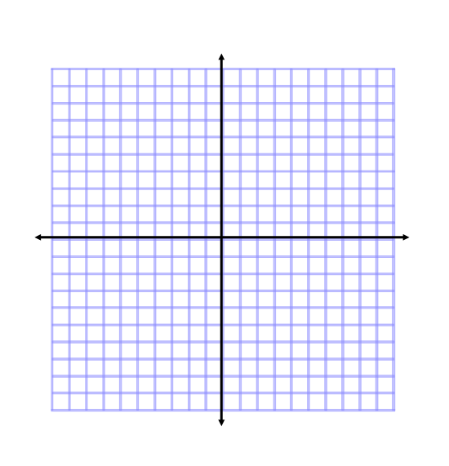Find the distance between the following 2 points on a coordinate plane: (-2, -5) and (3, 2) . Use graph paper if needed. Round answer to the nearest tenth if necessary.

Show your work here.

Answer: ____________

1. Two cars starting at the same place travel different directions. One car travels north at 45 mph. The other car travels east at 55 mph. How far apart will the cars be after 2 hours? Draw a picture of the situation and round your answer to the nearest tenth.

Show your work here.

Answer: ____________

1. Find the distance between the following 2 points on a coordinate plane:

(1,5), (8, 9). Use graph paper if needed. Round answer to the nearest tenth if necessary.



Show your work here.

Answer: ____________

1. A park is in the shape of a rectangle 3 miles long and 2.5 miles wide. How much shorter is your walk if you walk diagonally across the park rather than along two sides of it? Draw a picture of the situation and round your answer to the nearest tenth if necessary.

Show your work here.

Answer: ____________

1. Solve x2= 100

Show your work here.

Answer: ____________

1. 10,000
2. – 10
3. + 10
4. 10