Mathematics

Power Standard 8:3

Pre-Formative Test

Name _______________________________________________ Hour _________

1. (1.2)2+(3.2)2=

Show your work here.

Answer: _____________

1. 4.4
2. 3.42
3. 11.68
4. 19.36
5. Solve x2=31 and round your answer to the nearest tenth.

Show your work here.

Answer: ____________

1. Solve x2= 25

Show your work here.

Answer: _____________

1. x = 5
2. x = -5
3. both of the above
4. neither a nor b
5. If the sides of a right triangle are 5 cm, 3 cm, and 4 cm, identify the two legs and the hypotenuse. Between which 2 sides is the right angle?

Show your work here.

Answer: ____________

1. Solve the following equation. Round to the nearest tenth if necessary.

32+52=c2

Show your work here.

Answer: _____________

1. Graph the points (3,2) and (-1,5) on a coordinate plane. Find the distance between the two points. Round answer to the nearest tenth if necessary.

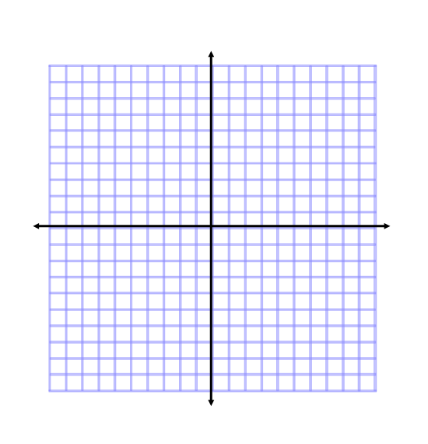

1. A building casts a shadow that is 15 meters in length. The distance from the top of the building to the top of the shadow is 25 meters. What is the height of the building?

Show your work here.

Answer: _____________