Mathematics

Power Standard 8:3

Post-Formative Test

Name _________________________________________________ Hour _______

Show work for each problem.

1. Solve x2=17 and round your answer to the nearest tenth.

Needs answer box work for work and answer

1. If the sides of a right triangle are 15 m, 9 m, and 12 m, identify the two legs and the hypotenuse. Between which 2 sides is the right angle?

Needs answer box work for work and answer

1. If the hypotenuse of a right triangle is 9.5 meters and one leg of the same triangle is 4.6 meters, find the length of the other leg. Round answer to the nearest tenth if necessary.

Needs answer box work for work and answer

1. If the two legs of a right triangle measure 3.2 inches and 5.9 inches, find the measure of the hypotenuse. Round answer to the nearest tenth if necessary.

Needs answer box work for work and answer

1. Solve the following equation. Round to the nearest tenth if necessary.

42+b2=152

1. 209
2. 14.4
3. 14.5
4. 15.5

Needs answer box work for work and answer

1. Find the distance between the following 2 points on a coordinate plane: (4,8) and (1,3). Use graph paper if needed. Round answer to the nearest tenth if necessary. Needs box for work

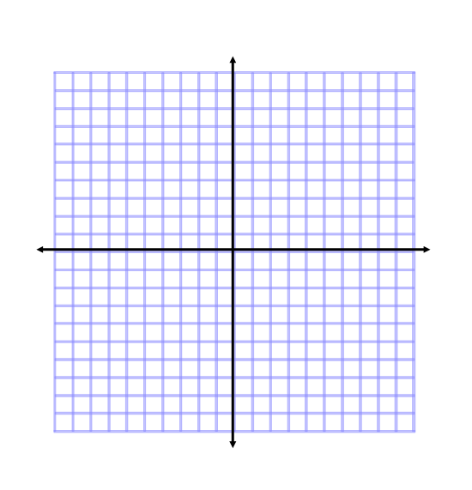

1. Two cars starting at the same place travel different directions. One car travels west at 65 mph. The other car travels south at 70 mph. How far apart will the cars be after 4 hours? Draw a picture of the situation and round your answer to the nearest tenth.

Needs answer box work for work and answer

1. Find the distance between the following 2 points on a coordinate plane: (2, 6) and (-3, 2). Use graph paper if needed. Round answer to the nearest tenth if necessary. Needs box for work



1. Suppose a ladder 25 feet long is placed against a vertical wall 25 feet high. How far would the top of the ladder move down the wall by pulling out the bottom of the ladder 8 feet? Explain your reasoning. Draw a picture of the situation and round your answer to the nearest tenth.

Needs answer box work for work and answer

1. Solve x2 = 81
2. 6561
3. -9
4. 9
5. b and c

Needs box for work