Communication Arts

Power Standard 8:4

Pre-Formative Test

Name _____________________________________________ Hour ___________

**DIRECTIONS: Read *Seat Belts.* Then answer questions 1, 2, and 3.**

1. Based on the information in the article, predict what the author would write about next. A. manufacturers of children’s car seats.

B. statistics on drunk driving.

C. the first car with seat belts.

D. laws related to wearing seat belts.

1. Which of the following statements best summarizes the section titled *“How Seat Belts Can*

*Stop You in a Crash”*?

A. Seat belts save over 10,000 lives in America every year.

B. People wearing seat belts are not ejected from the vehicle

C. A seat belt allows you to stop as the car is stopping.

D. People wearing seat belts are unlikely to strike the steering wheel.

1. From what point of view is the passage written? Use **one** detail from the text to support your answer. _________________________________________________________________________________________________________________________________________________________________________________________________________________________________________________________________________________________________________________________________________________________________________________________________________________________________________________________________________________________________________________________________________________________________________________________________________________________________________________________________________________________________________________________________________________________________________________________________

**DIRECTIONS: Read “The Odd Olympics of 1904”. Then answer questions 4 & 5.**

1. Which of the following sentences best summarizes the passage?
2. There were cheaters in the 1904 Olympics.
3. The 1904 Olympics were unimpressive.
4. Chicago and St. Louis battled to host the 1904 Olympics.
5. The current Olympic medal system originated in 1904.
6. Four runners from the 1904 Olympics are mentioned in the passage. What do the runners have in common?
7. All of the runners contributed to the oddness of the 1904 Olympics.
8. All of the runners cheated to try to win the 1904 Olympic marathon.
9. All of the runners represented foreign countries in the 1904 Olympics.
10. All of the runners had a desire to win the 1904 Olympic marathon.

**DIRECTIONS: Read “Art Built on Sand”. Then answer questions 6 –8.**

Use this graphic organizer for questions 6 & 7.

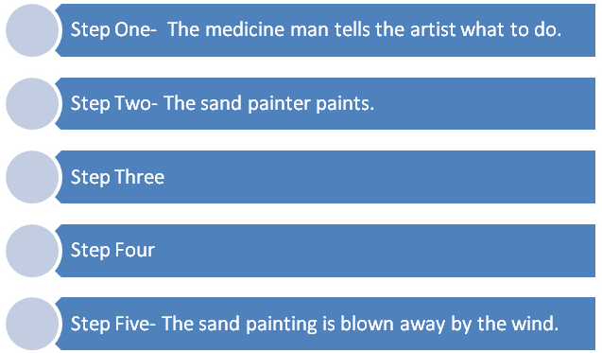

1. Which of the following best completes step three in the graphic organizer above?
2. The sand artist sprinkles sand onto the ground.
3. The sand artist has to re-paint the painting.
4. The elders sit in a circle and sing.
5. The medicine man blesses the painting.
6. Which of the following best completes step four in the graphic organizer above?
7. The sun sets on the sacred sand painting.
8. The artist makes straight lines and perfect angles.
9. Balance is restored between good and evil.
10. Tourists buy a non-sacred sand painting.
11. How do Navajo sand painters keep their paintings from having sacred power? Is this an effective solution? Explain why or why not using **one** detail from the text.

________________________________________________________________________________________________________________________________________________________________________________________________________________________________________________________________________________________________________________________________________________________________________________________________________________________________________________________________________________________________________________________________________________________________________________________________________________________________________________________________________________________________________________________________________________________________________________________________________________________________________________________________________________________________________________________________________________________________________