Communication Arts

Power Standard 8-1 & 8-2

Summative Test

Name ____________________________________________________________________ Hour _____________

1. How do the title and illustration give clues to the plot of the passage? Use two details to support your answer.

________________________________________________________________________________________________________________________________________________________________________________________________________________________________________________________________________________________________________________________________________________________________________________________________________________________________________________________________________________________________________________________________________________________________________________________________________________________________________________________________________________________________

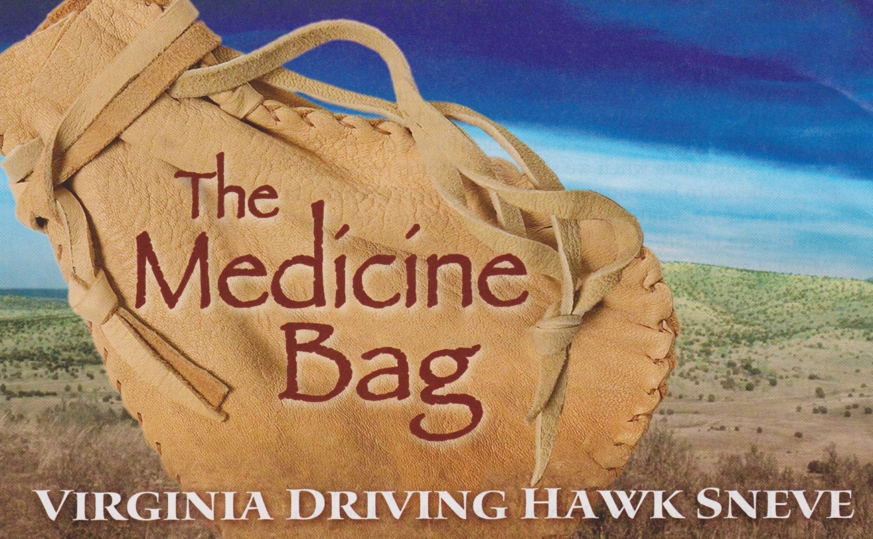

1. Explain how you know the following selection is a poem. Provide **two** details from the text to support your answer.

The Pasture

By Robert Frost

I’m going out to clean the pasture spring;

I’ll only stop to rake the leaves away

(And wait to watch the water clear, I may):

I shan’t be gone long, —You come too.

I’m going out to fetch the little calf

That’s standing by the mother. It’s so young

It totters when she licks it with her tongue.

I shan’t be long.—You come too.

________________________________________

________________________________________________________________________________________________________________________________________________________________________________________________________________________________________________________________________________________________________________________________________________________________________________________________________________

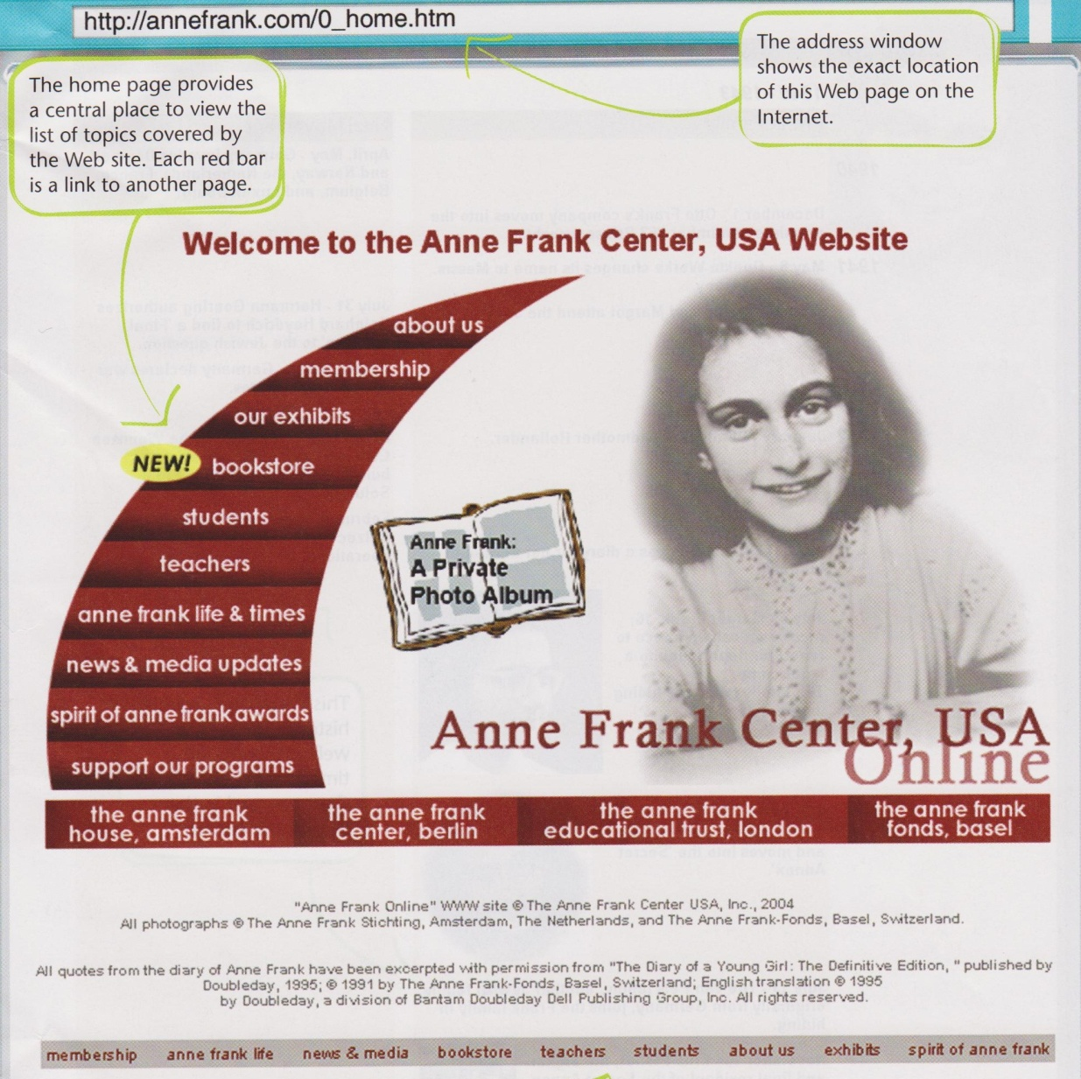

**Preview this homepage and answer the question below**.

1. Explain why some topics which appear in the center of the page are duplicated on the bar across the bottom of the page.

__________________________________

__________________________________

__________________________________

__________________________________

__________________________________

__________________________________

__________________________________

__________________________________

__________________________________

__________________________________

__________________________________

4. Using your knowledge of root words and affixes, break apart and explain the meaning of the word

*nonsequential*.

_____________________________________________________________________________________________________________________________________________________________________________________________________________________________________________________________________

**Read the following passage.**

The inspector was completely baffled in trying to look for clues to solve the crime. In spite of looking for two days, not one footprint or fingerprint or any other piece of tangible evidence was found at the crime scene.

5. Based on how the word baffled is used in the sentence, what does it mean? Identify a context

clue that helped you figure it out.

____________________________________________________________________________________________________________________________________________________________________________________________________________________________________________________________________________________________________________________________________________________________

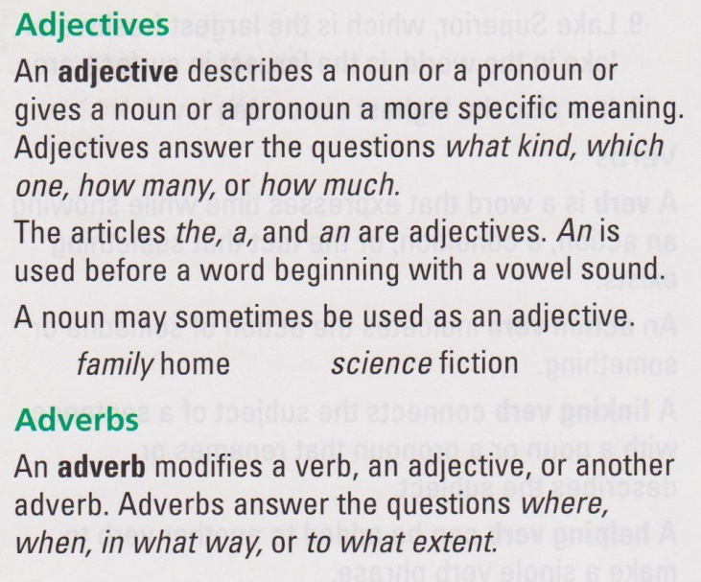6. Based on the information on this page,

what topics would you expect to learn about?

1. Literary elements
2. Grammar
3. Writing process
4. Poetry

7. Which prefix would you add to the word *regular* to make a new word that means *not conformed*?

1. non-
2. in-
3. en-
4. ir-

8. Which suffix would you add to the root word *happy* to make a new word meaning *a state of being*

*happy*?

1. –ness
2. –ity
3. –ition
4. -eous

9. In a textbook, which one of the following is a likely place to locate a word definition?

1. index
2. footnote
3. map
4. table of contents

10. Which of the following group of words is correctly alphabetized?

1. cereal, coffee, candy
2. junk, joke, jet
3. water, well, worm
4. gush, gross, gas

11. The word monkey would appear between which two guide words?

1. money-monopoly
2. mad-matter
3. mature-maze
4. mister-misty

**Read the following glossary entries and answer the question below.**

**baseplate:** the rectangular metal piece that allows a skateboard’s truck to be bolted onto the underside of the deck

**deck:** the flat, long part of the skateboard the rider stands on; the board itself

**kingpin:** the bolt that runs through the center of a skateboard truck and holds it together

**truck:** the T-shaped piece of metal mounted to the underside of the skateboard’s deck and attached to two of the wheels

12. If you read the definition for *baseplate* first, what other word entries might you need to read in

order to fully understand the definition of *baseplate*?

1. kingpin and deck
2. deck and baseplate
3. truck and kingpin
4. truck and deck