Mathematics

Power Standard 7:8

Formative Test

Name __________________________________________________________ Hour __________

1. Robert wants to make a graph of how many visitors attend 5 different national zoos annually. What type of graph would best represent Robert’s data?
2. line plot
3. line graph
4. bar graph
5. circle graph
6. Based on the graph below, what portion of the import economy makes up about $\frac{1}{4 }$ of the US imports?

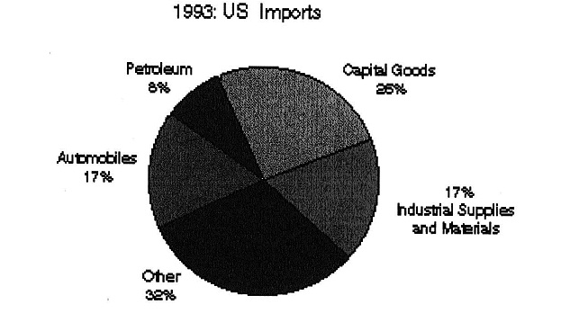

1. Industrial Supplies and Materials
2. Capital Goods and Petroleum combined
3. Capital Goods
4. Other
5. Create a histogram of the following data about the speed of various land animals.

|  |  |
| --- | --- |
| **Maximum Speed (mph)** | **Frequency** |
| 0-9 | 1 |
| 10-19 | 0 |
| 20-29 | 5 |
| 30-39 | 10 |
| 40-49 | 8 |
| 50-59 | 6 |
| 60-69 | 2 |

1. Natalie runs 4 miles on Mondays, 3.5 miles on Wednesdays, and 4.5 miles on Fridays. Which measure of central tendency would not be affected if Natalie chooses to add a 3.5 mile jog on Sundays?
2. mean
3. median
4. mode
5. range
6. Find the mean median, mode, and range of the following data. Round to the nearest tenth, if necessary.

29, 14, 80, 59, 78, 30, 59, 69, 55, 50

1. The graph below shows the ethnicity of Macon Middle School students. If there are 850

students at the school, about how many more Caucasian students are there than African American students?

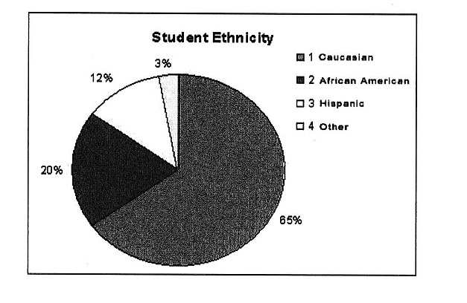

1. A circle graph shows that 16% of the world’s population speaks English. This section of the circle graph would measure:

A. 16˚

B. 25˚

C. 38˚

D. 58˚