MPS7:8Post-Formative Scoring Guide

ITEM# | SR | CR | PT | GLE | OBJ | EXP | DESCRIPTOR
1. | B |  | 1

ITEM# | SR | CR | PT | GLE | OBJ | EXP | DESCRIPTOR
2. | C |  | 1

ITEM# | SR | CR | PT | GLE | OBJ | EXP | DESCRIPTOR
3. |  | X | 2
Answer: Sample Answer:
Speed of Land Animals

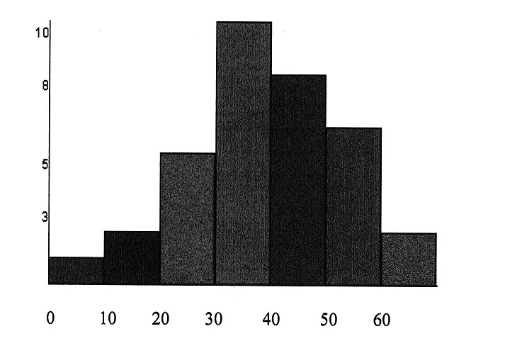
2 points: Exemplary response; histogram titled, correct intervals (no gaps or overlaps, intervals are consistent, correct frequency on y-axis), explanation of usefulness correct.
1 point: 2-3 of the above elements
O points: None of the above elements are correct.
ITEM# | SR | CR | PT | GLE | OBJ | EXP | DESCRIPTOR
4. | D |  | 1

ITEM# | SR | CR | PT | GLE | OBJ | EXP | DESCRIPTOR
5. |  | X | 1
Answer: 52.3; 57; 59; 64
4 points: Exemplary response; all 4 measures correctly given
3 points: 3 measures correctly given
2 points: 2 measures correctly given
1 point: 1 measure correctly given
0 points: no measures correctly given
ITEM# | SR | CR | PT | GLE | OBJ | EXP | DESCRIPTOR
6. |  | X | 1
Answer: 383 students
2 points: Exemplary response; correct answer and work given
1 point: Correct answer OR correct work given
0 points: Neither correct answer nor correct work given
ITEM# | SR | CR | PT | GLE | OBJ | EXP | DESCRIPTOR
7. | D |  | 1

