Willard Middle School – Mathematics

SUMMATIVE TEST – Power Standard 7:6

Name __________________________________________________________ Hour _____________

1. Justin bought a new baseball glove for $35. It is too small so he plans to sell it. If he sells it to his cousin for $45, what percent of profit did he make?
2. 10%
3. 15%
4. 29%
5. 45%
6. Find the unit rate of $1.98 for 6 cans of soda.
7. Which car has the higher unit rate: A car travelling 360 miles in 4.5 hours or a car travelling 498 miles in 6 hours.
8. Does the graph below represent a constant rate of change? Explain your reasoning.

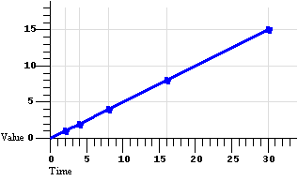

1. 55 is 40% of what number? Use the percent proportion to find your answer.
2. Are $\frac{12}{17}$ and $\frac{24}{34}$ equivalent? Explain your reasoning.
3. Jim found out that after working for 9 months he had earned 6 days of vacation time. How many days will he have earned after working for two years? Use a proportion to find your answer.
4. Ruth makes a scale drawing of her room. She uses the scale 2.5 in: 1 ft. In the drawing, the dimensions of her room are 18 in. by 24 in. What are the actual dimensions of her room?
5. A rectangle is dilated by a factor of 3. If the original perimeter is 16 inches, what is the new perimeter?
6. 16 inches
7. 19 inches
8. 32 inches
9. 48 inches