Mathematics
Power Standards 7:4
Pre-Formative Test
Name _____________________________________________ Hour ___________
- Which of the following is an example of an arithmetic sequence?
- -3, 0, 2, 3, 5….
- -12, -7, -2, 3, 8….
- 0, 2, 4, 8, 16…..
- 1, 2, 4, 5, 7….
- Which ordered pair represents a correct domain and range for the graphed line of y=12x+5?
- (0, 12)
- (1, 12)
- (2, 29)
- (3, 42)

- Which of the following represents a function?
- (2, 4), (5, 2), (2, 5), (4, 9), (6,8)
- (1, 4), (3, 2), (2, 2), (4, 0), (6,-3)
- (5, 6), (4, 2), (5, 6), (3, 1), (1,1)
- (2, 4), (6, 2), (3, 5), (4, 9), (6,8)

- Which table represents a linear function?
- b.
X | y
-2 | -1
0 | 0
2 | 1
4 | 3
6 | 5
x | y
-5 | 1
-3 | 2
-1 | 3
1 | 4
3 | 5
c. d.
x | y
0 | 0
1 | -1
2 | -2
3 | -4
4 | -8
x | y
-4 | 1
-3 | 2
-1 | 3
0 | 4
1 | 5

- List the numbers that are part of the range of the following set of ordered pairs.
(0, 2), (1, 4), (2, 6), (3, 8), (4, 10)

- Write an equation that represents the graphed line on the following coordinate plane?
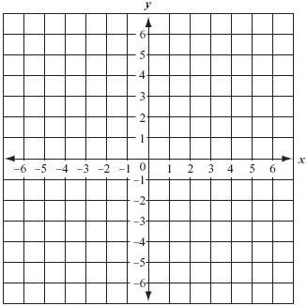

- Describe the relationship between the terms in the following arithmetic sequence and
write the next three terms: 20, 45, 70, 95….

- What is the 7th term of the following pattern?

2, 8, 32, 128…

- Which of the following equations is true for the three pairs of x and y values in the table below?

x | y
0 | -3
1 | -1
2 | 1
- 3 x + 2 = y
- 3 x - 2 = y
- 2 x + 3 = y
- 2 x - 3 = y

- Identify the next three terms in the pattern 4, 8, 12, 16, …

A. 18, 20, 21
B. 20, 24, 28
C. 18, 22, 26
D. 32, 48, 64

- Which of the following is the rule for the following pattern:

A. add four
B. add four, subtract two
C. add four, subtract three
D. add three, subtract four

