Mathematics

Power Standard 7:12

Summative Test

Name __________________________________________________________ Hour __________

1. Find the volume of the rectangular prism below.

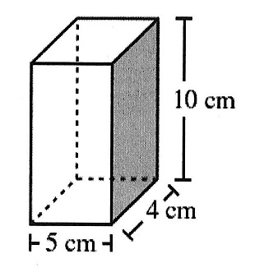

1. Find the volume of the right triangular prism below.

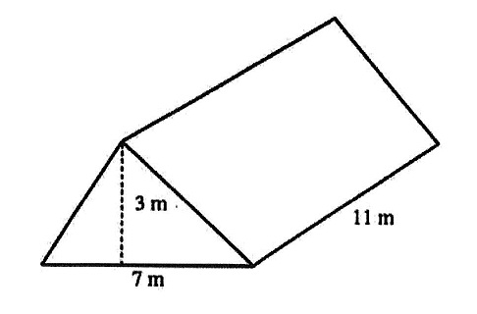

1. A graduated cylinder has a diameter of 18 millimeters and is 250 millimeters tall. What is the volume of the cylinder? Use 3.14 for $π$ and round to the nearest tenth, if necessary.