Mathematics

Power Standard 7:12

Pretest

Name __________________________________________________________ Hour __________

1. Find the volume of the triangular prism below.

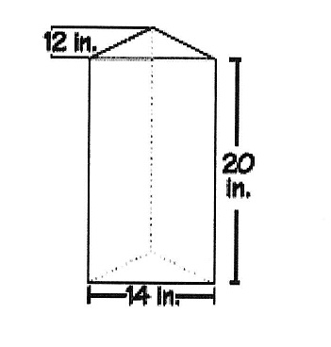

1. Find the volume of the cylinder below. Use 3.14 for $π$. Round to the nearest tenth, if necessary.

