Mathematics

Power Standard 7:12

Formative Test

Name __________________________________________________________ Hour __________

1. Find the volume of the rectangular prism below.

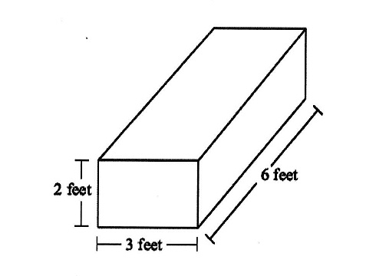

1. Find the volume of the right triangular prism below.

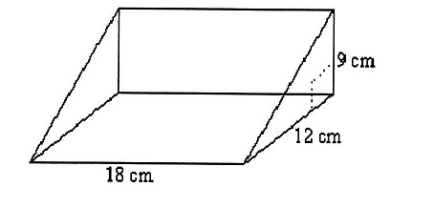

1. Find the volume of the potato chip can below. Use 3.14 for $π$. Round to the nearest tenth, if necessary.

