Mathematics

Power Standard 7:10

Pre-Formative Test

Name ___________________________________________________ Hour __________

1. Use a protractor to measure the following angle.

1. Classify the following angle.
2. acute
3. straight
4. obtuse
5. right
6. Rectangle WXYZ has a length of 8 m and a width of 6 m. Which of the following would be the dimensions of a rectangle that is similar to Rectangle WXYZ?
7. 4 m by 2 m
8. 15 m by 12 m
9. 32 m by 18 m
10. 48 m by 36 m
11. Find the value of *x* in the following pair of similar figures.

20 m 4 m

7 m

x

1. If two rectangles are similar and the ratio of their corresponding sides is 1:4. What is the ratio of their perimeters? Explain your reasoning.
2. A fire hydrant 2.5 feet high casts a 5-foot shadow. How tall is a street light that casts a 26-foot shadow at the same time?
3. 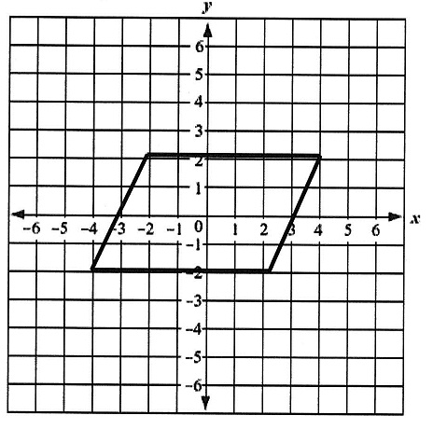The following graphed figure is a:
4. trapezoid
5. rectangle
6. rhombus
7. parallelogram
8. On the coordinate plane shown below, draw a rectangle with its vertices at the points

(2, -2), (8, -2), 8, 8), (2, 8). What is the area, in square units, of this rectangle?

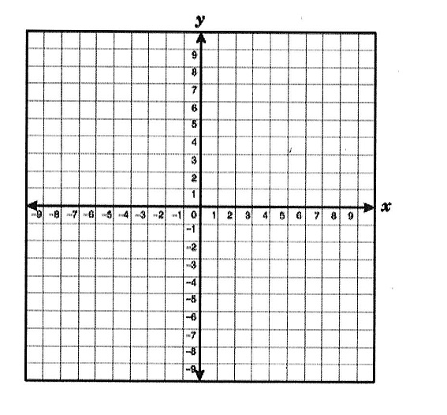

1. The following figure has how many lines of symmetry?
2. 0
3. 1
4. 2
5. 3