Communication Arts

Power Standard 7:1 & 7:2

Pre-Formative Test

Name ___________________________________________________________________________ Hour ____________

1. The excerpt below is from the table of contents of a literature book. Identify one text feature and explain how it helps readers better understand the textbook. ________________________________________________________________________________________________________________________________________________________________________________________________________________________________________________________________________________________________________________________________________________

MEETING CHALLENGES

Anne Dillard Marjorie Kinnan Rawlings

*from* **An American Childhood** Autobiography . . 52 **Rattlesnake Hunt** Narrative Essay. . . . . . . .459

Rudyard Kipling **How to Recognize Venomous Snakes in**

**Rikki-tikki-tavi**  Short Story . . . . . . . . . . . . . . . . .. 199 **North America** Manual. . . . . . . . . . . . . . . . .469

Larry Luxner James Thurber

**Mongoose on the Loose** Magazine Article . . . . 219 **The Night the Bed Fell** Humorous Essay . . 477

Karen Hesse Naomi Shihab Nye

*From* **Letters from Rifka** Short Story . . . . . . . . . . 224 **The Rider** Lyric Poem . . . . . . . . . . . . . . . . . 520

Piri Thomas Alfred Noyes

**Amigo Brothers** Short Story . . . . . . . . . . . . . . . . . 283 **The Highwayman**  Lyric Poem . . . . . . . . . .558

**Walking for Exercise and Pleasure**  Gregory Djanikian

Government Publication . . . . . . . . . . . . . . . . . . . .297 **How I Learned English**  Narrative Poem . 567

Nancy Masterson Sakamoto Laurence Yep

**Conversational Ballgames**  Expository Essay . . .379 *excerpt from* **Dragonwings** Novel . . . . . . .649

*excerpt from***Dragonwings** Play . . . . . . . ..651

Russell Baker

**No Gumption** Autobiography . . . . . . . . . . . . . . . 416 Alice Low

**Perseus** Myth . . . . . . . . . . . . . . . . . . . . . . . 872

Louis L’Amour

**The Eternal Frontier** Persuasive Essay . . . . . . . . 438 Virginia Hamilton

**The People Could Fly**

Geoffrey C. Ward African American Folk Tale . . . . . . . . . . . 914

**The Real Story of a Cowboy’s Life**

Expository Essay . . . . . . . . . . . . . . . . . . . . . . . . . . 452

1. 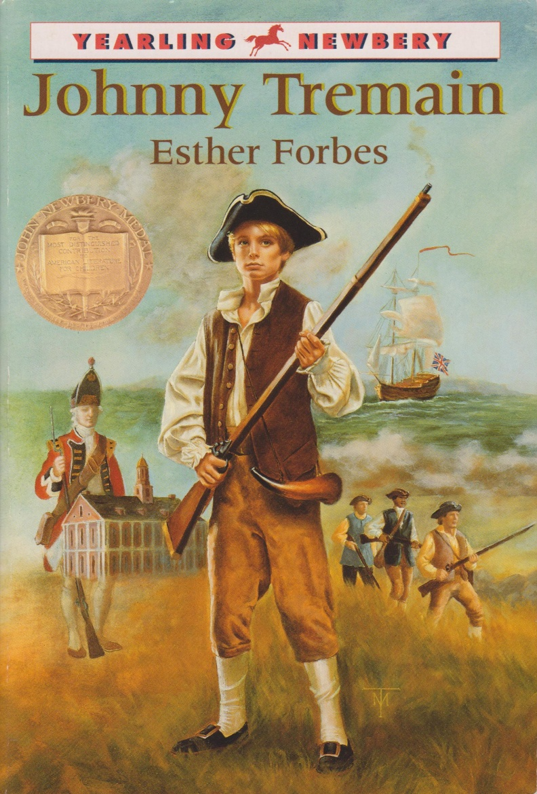Based on the title and cover illustration,

predict what you think the novel will be

about. Provide **two** details from the cover to support your answer.

________________________________________

________________________________________

________________________________________

________________________________________

________________________________________

________________________________________

________________________________________

________________________________________

________________________________________

________________________________________

________________________________________

________________________________________

________________________________________

________________________________________

________________________________________

1. Using your knowledge of root words and affixes, break down and explain the meaning of the word ***misinformation****.*

____________________________________________________________________________________________________________________________________________________________________________________________________________________________________________________________________________________________________________________________________________________________________________

1. Which of the following is NOT part of a play?
2. setting
3. summary
4. character list
5. dialogue
6. Which of the following is NOT true of technical manuals?
7. Manuals often include labeled illustrations.
8. Manuals often include safety warnings
9. Manuals often include a list of steps to follow.
10. Manuals often include an index and a glossary of terms.
11. Which of the following is an example of a prefix?
12. en
13. ic
14. ment
15. mis
16. Which of the following is an example of a suffix?
17. able
18. de
19. dis
20. fore

**Read the following passage and answer the question below.**

His father did not intend to be cruel, but he was himself a hard-working man, an early riser, and a swift workman, and it seemed a natural and necessary thing to have his sons work. He himself had been bound out at nine years of age, and he had never known a week’s release from toil.

1. What does the word ***toil***mean in this passage?
2. vacation
3. parenting
4. hard work
5. rest and relief
6. Where would you most likely find a glossary in your textbook?
7. in the front of the book
8. in the middle of the book
9. at the end of each chapter
10. at the end of the book
11. Which of the following words would appear first in the dictionary?
12. albatross
13. apple
14. Albany
15. asthma
16. Which of the following words would be on a dictionary page with the guide words ***caring –* *carrot****?*
17. campus
18. caramel
19. caricature
20. carol

**Use the dictionary entry to answer the question below.**

**poll** (pol) n. **1)** the head **2)** a counting, listing of persons **3)** the number of votes **4)** a place voting takes place **5)** asking a person’s opinion on some question or issue

John decided to **poll** the people in his neighborhood to get an idea of how they felt

about the results of the election

1. What is the best meaning of the word *poll* as it is used in the sentence above?
2. meaning 1
3. meaning 2
4. meaning 3
5. meaning 5
6. Which of the following would be the most appropriate research tool to find synonyms for a word?
7. glossary
8. thesaurus
9. dictionary
10. index