Communication Arts

Power Standard 7:1 & 7:2

Post-Formative Test

Name _________________________________________________________________________Hour ______

1. Explain how the author’s use of italics or bold faced print in a text helps the reader.

________________________________________________________________________________________________________________________________________________________________________________________________________________________________________________________________________________________________________________________________________________

____________________________________________________________________________________

1. How do the title and picture give clues about the content of the story? Provide **two** details from the text to

support your answer.

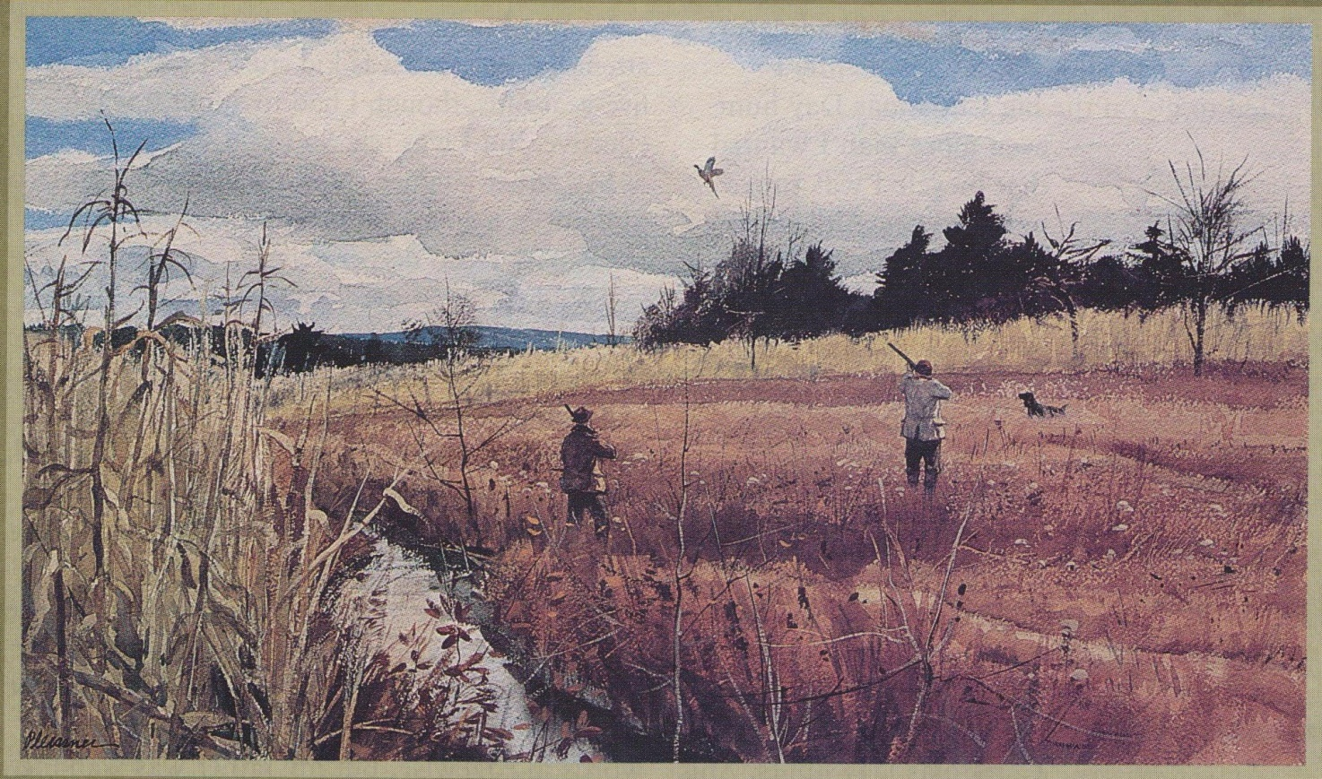

____________________________________________________________________________________________________________________________________________________________________________________________________________________________________________________________________________________________________________________________________________________________________________________________________________________________________________________________________________________________________________________________________________________________________________________________________________

1. Explain why an author would include color photographs in an article titled ***How to Recognize Venomous Snakes in North America.***

____________________________________________________________________________________________________________________________________________________________________________________________________________________________________________________________________________________________________________________________________________________________________________________________________________________________________

1. Read the following poem. On the lines below, explain why the author chose to arrange the lines of the poem this way. Provide one detail from the text to support your answer.

_______________________________________________________________________________________________________________________________________________________________________________________________________________________________________________________________________________________________________________________________________________________________________________________________________________________________________________________________________

SEAL

William Jay Smith

See how he dives

From the rocks with a zoom?

See how he darts

Through his watery room

Past crabs and eels

And green seaweed,

Past fluffs of sandy

Minnow feed?

See how he swims

With a swerve and a twist,

A flip of the flipper,

A flick of the wrist!

Quicksilver-quick,

Softer than spray,

Down he plunges

And sweeps away;

Before you can think,

Before you can utter

Words like “Dill pickle”

Or “Apple butter,”

Back up he swims

Past Sting Ray and Shark,

Out with a zoom,

1. A whoop, a bark;
2. Before you can say
3. Whatever you wish,
4. He plops at your side
5. With a mouthful of fish!
6. Using your knowledge of root words and affixes, break apart and explain the meaning of the word

***disenchanted****.*

____________________________________________________________________________________________________________________________________________________________________________________________________________________________________________________________

____________________________________________________________________________________

6. Which of the following is NOT a text feature of poetry?

1. rhyming
2. paragraphing
3. white space
4. stanzas

7. What is the meaning of the prefix ***dis-?***

1. for
2. not
3. half
4. wrongly

8. What is the meaning of the suffix **-*able****?*

1. half
2. before
3. can be done
4. opposite of

**Read the following sentences and answer the question below.**

Not all commercial websites are untrustworthy. Indeed, many commercial sites are reputable.

1. Using context clues, determine the correct meaning of the word ***reputable****.*
2. useful
3. reliable
4. suspicious
5. complicated
6. Which one of the following is NOT a likely place to find the definition of a word in a textbook?
7. glossary in back of the book
8. at the top of a page
9. footnote at the bottom of a page
10. in the text itself
11. Which of the following words are correctly alphabetized?
12. monkey, mania, market
13. carrot, church, clam
14. violin, vixen, valet
15. butter, banner, buffet
16. The word ***bottle*** would appear between which of the following guide words?
17. boat – bottom
18. butcher – bugle
19. book - boorish
20. bagel – battery

**Use the dictionary entry to answer the question below.**

**poll** (pol) n. **1)** the head **2)** a counting, listing of persons **3)** the number of votes **4)** a place voting takes place v. **5)** to ask a person’s opinion on some question or issue

1. What is the best meaning for the word “poll” as it is used in the following sentence?

John went to the **poll** to see if his mother was helping with the election.

1. meaning 1
2. meaning 2
3. meaning 3
4. meaning 4
5. Which of the following statements is**­­** NOT true about a dictionary and a thesaurus?
6. Both have guide words.
7. Both are arranged alphabetically.
8. Both tell parts of speech.
9. Both have an index.