**Mathematics**

**Power Standard 8:7**

**Pretest**

**Name ___________________________________ Hour __________**

1. Describe the following situation: As the temperature outside goes

up, the air conditioning bill goes up.

A. positive relationship

B. no relationship

C. negative relationship

D. neutral relationship

2. Solve for x. -3x+2=11

Show steps

3. Jean starts her savings account with $100. Starting the next week

she deposits $20 in her account each week. Write and solve an

equation showing how many weeks it will take until she has saved a

total of $260.

4. Identify the slope and y-intercept of the following:

Y=()x+6

M=___________ b=__________

5. Given the following graph of a linear function. Write the equation of

the line.

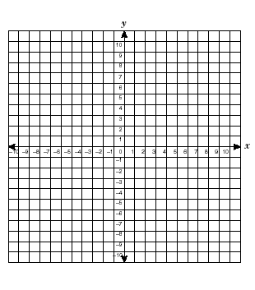

6. Graph y = ($\frac{3}{2}$) x-4. Identify the slope and y-intercept.

M=___________ b=_______________



7. Use the following t-bar to make a scatter plot. Use a line of fit to

predict the shoe size of a 6’5” man.

Ht. in Inches Shoe Size

72 11

60 6.5

62 8

63 7.5

59 6.5

70 10



8. Use the following table to answer the following questions

Time 1:00 1:05 1:10 1:20

Envelopes stuffed 15 25 40 70

What was the rate of change between 1:00 and 1:05?