**Mathematics**

**Power Standard 8:7**

**Pretest Scoring Guide**

1. A
2. -3x+2=11

-3x=9

X=-3

2 points: Exemplary response; correct steps and correct answer

1 point: Either correct answer or correct steps, but not both

0 point: Neither correct answer nor correct steps.

1. 260=20x+100; x=8 weeks

2 points: Exemplary response; correct equation and correct answer

1 point: correct equation or correct answer, but not both

0 point: neither equation nor answer is correct

1. M= $\frac{1}{2}$, b=6

2 points: Exemplary response; correct slope and correct y-intercept

1 point: correct slope or correct y-intercept, but not both

0 point: neither slope nor y-intercept is correct

1. Y=($\frac{3}{2}$)x+2

2 points: Exemplary response; correct form, correct slope, and correct y-intercept

1 point: one of the above criteria correct

0 point: None of the above criteria correct

1. Graph y=($\frac{3}{2}$)x-4. Identify the slope and y-intercept.

M= $\frac{3}{2}$, b=-4

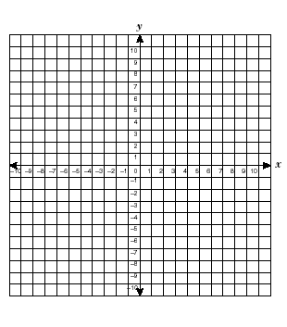

3 points: Exemplary response: graph is correct, correct slope, and correct y-intercept.

2 points: 2 of the above criteria correct

1 point: 1 of the above criteria correct

0 point: none of the above criteria correct.

1. Size 11.5



3 points: Exemplary response: graph is correct, line of fit is reasonable, prediction is reasonable

2 points: 2 of the above criteria is correct

1 point: 1 of the above criteria is correct

0 point: none of the above criteria is correct

1. 2 envelopes / minute

2 points: Exemplary response: correct answer and in reduced form

1 point: correct answer not in reduced form

0 point: incorrect answer