Pre-Test answers

1. D
2. B
3. A
4. Example answer:

Use the following test scores to create a histogram: 98,67,88,87,95,73,74,89,86,99,67,70,72,73,69,94,86,96,94

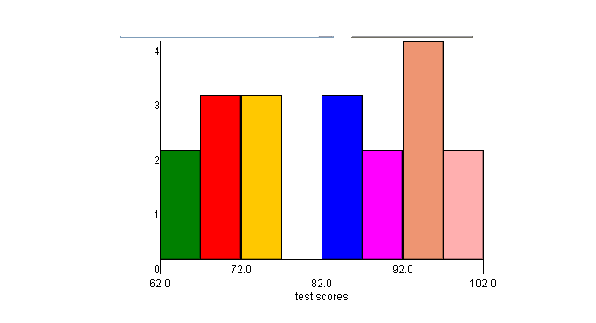

2 points: Exemplary response; histogram titled, correct intervals (no gaps or overlaps, intervals are consistent, correct frequency on y-axis), explanation of usefulness correct.

1 point: 2-3 of the above elements are correct.

0 points: none of the above elements are correct.

1. Example answer: Make a bar graph and don’t start the y-axis counting at “0”, make a bar graph and don’t use consistent intervals, make a picto-graph and use distorted pictures.

2 points: Exemplary response; 2 correct methods explained.

1 point: 1 correct method explained.

0 points: No correct method explained.

1. Example answer: 1,2,3,4,5,6,6,8,8,8,8

2 points: Exemplary response; both mode and median are correct for set of data given.

1 point: Either mode or medians is correct, but not both.

0 points: Neither mode or median is correct.