Willard Middle School – Mathematics

SUMMATIVE TEST – Power Standard 8:3

Name _______________________________________________ Hour _________

Show work for each problem

1. Divide 64 by 34 and round your answer to the nearest hundredth.
2. (3.6)2+(6.1)2=____
3. Solve x2=110 and round your answer to the nearest tenth.
4. If the sides of a right triangle are 25 in., 15 in., and 20 in., identify the two legs and the hypotenuse. Between which 2 sides is the right angle?
5. Solve the following equation. Round to the nearest tenth if necessary. 52+162=c2
6. Graph the points (-2, -5) and (3, 2) on a coordinate plane. Find the distance between the two points.

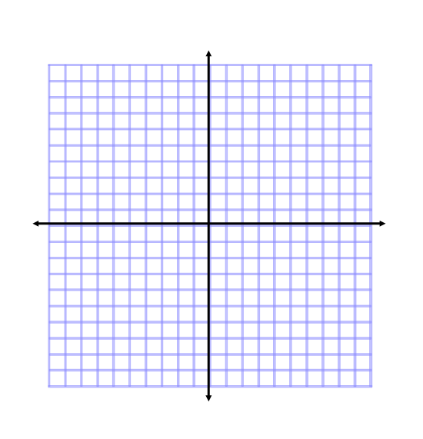

1. Two cars starting at the same place travel different directions. One car travels north at 45 mph. The other car travels east at 55 mph. How far apart will the cars be after 2 hours? Draw a picture of the situation and round your answer to the nearest tenth.