Mathematics

Power Standard 7:10

Summative Test

Name __________________________________________________________ Hour __________

1. Joshua surveyed his classmates about their favorite foods. He found that 25% prefer chicken, 40 % prefer pizza, 13% prefer pasta, and 22% prefer other things. What type of graph should Josh make to display his data?
2. circle graph
3. bar graph
4. histogram
5. stem-an-leaf plot
6. Of the five companies shown on the graph, how many of them shipped less than they received?

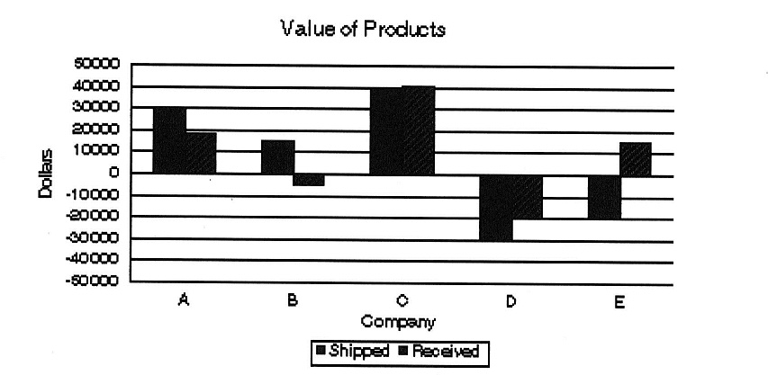

1. 0
2. 2
3. 3
4. 5
5. Make a circle graph of the following data.

|  |  |
| --- | --- |
| **Type of Movie** | **Percent** |
| Action | 48 |
| Comedy | 30 |
| Science Fiction | 22 |

-------------------------------------------------

1. Which measure of central tendency best describes the data in the chart below?

|  |  |
| --- | --- |
| **Known Mountains of Mars** | |
| **Mountain** | **Height (km)** |
| Alba Patera | 3 |
| Arsia Mons | 9 |
| Ascraeus Mons | 11 |
| Olympus Mons | 27 |
| Pavonis Mons | 7 |

1. mean
2. median
3. mode
4. range
5. Find the mean median, mode, and range of the following data. Round to the nearest tenth, if necessary.

27, 56, 34, 19, 41, 56, 27, 25, 34, 56

1. The graph below shows the ethnicity of Macon Middle School students. If there are 850

students at the school, about how many students are NOT Caucasian, African American, or Hispanic?

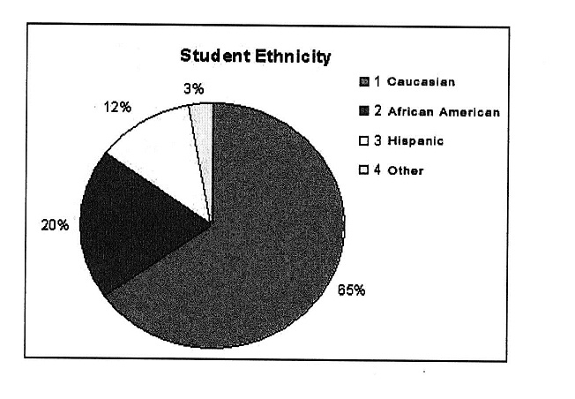

1. WMS students were surveyed about their favorite color. The survey concluded that 23% of the students preferred blue. How many degrees would this section measure on a circle graph?

A. 23˚

B. 33˚

C. 54˚

D. 83˚