Willard Middle School – Mathematics

Pretest – Power Standards: 7.4 and 7.5

Name ______________________________________________________ Hour __________

1. Which of the following is an example of an arithmetic sequence?
2. -3, 0, 2, 3, 5….
3. -12, -7, -2, 3, 8….
4. 0, 2, 4, 8, 16…..
5. 1, 2, 4, 5, 7….
6. Which algebraic expression represents the following:

*Twelve less than twice her age*

1. 12 – 2x
2. 12x – 2
3. 12-2
4. 2x – 12
5. Simplify 4x +5y + 3x
6. 7x + 5y
7. 12 x
8. 12xy
9. 7y +5x
10. Simplify 3(2x – 5) using the distributive property.
11. 6x -15
12. 6x – 5
13. 2x -15
14. 6x + 15
15. Evaluate 84 – x, if x=16.
16. 100
17. 78
18. 68
19. 54
20. Which ordered pair would the graphed line of y=12x+5 pass through?
21. (0, 12)
22. (1, 12)
23. (2, 29)
24. (3, 42)
25. Which of the following represents a function?
26. (2, 4), (5, 2), (2, 5), (4, 9), (6,8)
27. (1, 4), (3, 2), (2, 2), (4, 0), (6,-3)
28. (5, 6), (4, 2), (5, 6), (3, 1), (1,1)
29. (2, 4), (6, 2), (3, 5), (4, 9), (6,8)
30. Which table represents a linear function?

a.

|  |  |
| --- | --- |
| x | y |
| -2 | -1 |
| 0 | 0 |
| 2 | 1 |
| 4 | 3 |
| 6 | 5 |

b.

|  |  |
| --- | --- |
| x | y |
| -5 | 1 |
| -3 | 2 |
| -1 | 3 |
| 1 | 4 |
| 3 | 5 |

c.

|  |  |
| --- | --- |
| x | y |
| 0 | 0 |
| 1 | -1 |
| 2 | -2 |
| 3 | -4 |
| 4 | -8 |

d.

|  |  |
| --- | --- |
| x | y |
| -4 | 1 |
| -3 | 2 |
| -1 | 3 |
| 0 | 4 |
| 1 | 5 |

9. List the numbers that are part of the range of the following set of ordered pairs.

(0, 2), (1, 4), (2, 6), (3, 8), (4, 10)

10. Write an equation that represents the graphed line on the following coordinate plane?

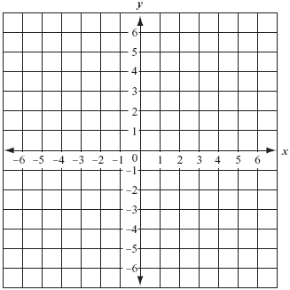

11. Describe the relationship between the terms in the following arithmetic sequence and

write the next three terms: 20, 45, 70, 95….

12. What is the 7th term of the following pattern?

2, 8, 32, 128…

13. Solve x – 13 = 21

14. Solve 3x +17 = 47