Willard Middle School – Mathematics
FORMATIVE – Power Standards 7:4 & 7:5
Name _________________________________________________________________ Hour __________

- Which of the following is an example of a geometric sequence?
- 2, 6, 18, 54….
- 2, 4, 12, 24…
- 2, 4, 6, 8…
- 2, 8, 12, 16…
- Which algebraic equation represents the following:
One half the regular price is $13
- x ÷2 = 13
- 2x = 13
- 2 ÷x = 13
- ½ ÷ x = 13

- Simplify 12p – 4p + 7p
- 23p
- 8p + 7p
- p
- 15p

- Simplify 5(3y + 7) using the distributive property.
- 3y – 35
- 15y + 35
- 15y + 7
- 15y – 35

- Evaluate 3p + 5, if p=12.
- 20
- 41
- 53
- 317

- Which equation represents the relationship shown in the following table?
x | y
1 | 5
2 | 15
3 | 25
4 | 35
5 | 45

- y=15x-15
- y=5x + 5
- y = 5x
- y = 10x – 5

- Which of the following represents a function?
- (1, 1), (2, 1), (1, 2), (4, 3), (5, 4)
- (1,1), (2, 2), (3, 3), (4, 4), (5, 5)
- (1,1), (1, 2), (1, 3), (1, 4), (1, 5)
- (1, 1), (2, 3), (3, 5), (5, 7), (5, 9)

- Which table represents a non-linear function?

a.
x | y
0 | -1
1 | -5
2 | -9
3 | -13
4 | -17

b.
x | y
0 | 1
1 | 3
2 | 5
3 | 7
4 | 9

c.
x | y
0 | 0
1 | -1
2 | -2
3 | -4
4 | -8

d.
x | y
0 | 0
1 | 1
2 | 2
3 | 3
4 | 4

9. List the numbers that are part of the domain of the following set of ordered pairs.
(-2, -1), (1, 4), (4, 9), (7, 14), (10, 19)

10. Graph the equation y = 2x - 4 on the coordinate plane below.
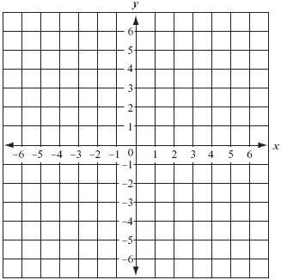

11. Describe the relationship between the terms in the following arithmetic sequence and write the next three terms: 2.4, 3.2, 4.0, 4.8 . . .

12. Solve 4p = 64

13. What is the 100th term of the following pattern?

14, 28, 42, 56 . . .

14. Solve 8y – 6 = 90

