Mathematics

Power Standard 7:11 an d 7:12

Summative Test

Name __________________________________________________________ Hour __________

1. Which of the following correctly describes the relationship between the radius and diameter of a circle?
2. The diameter is half the radius.
3. It takes two radii to equal a diameter.
4. The radius is twice the diameter.
5. It takes two diameters to equal one radius.
6. A mysterious crop circle was found in England. It was created in a single night by an unknown source and had a diameter of 250 ft. What is the circumference of the circle?
7. A CD has a diameter of 12 centimeters. The hole in the middle of the CD has a diameter of 1.5 centimeters. Find the area of one side of the CD to the nearest tenth. Use 3.143 for $π$.
8. Find the surface area of the rectangular prism below.

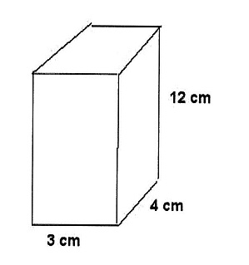

1. Find the volume of the rectangular prism below.

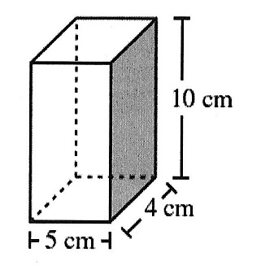

1. Find the surface area of the triangular prism below. (Hint: the length of *a* is 5 units*.)*

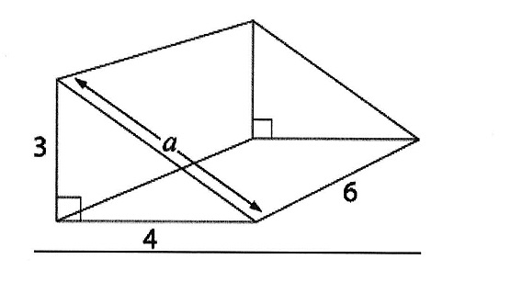

1. Find the volume of the right triangular prism below.

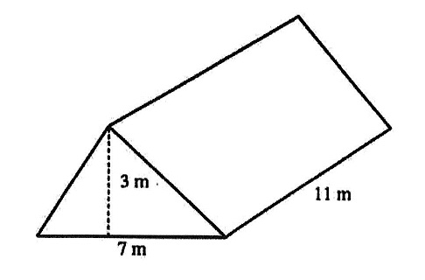

1. 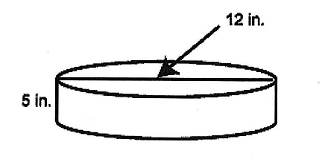Find the surface area of the cylinder below. Use 3.14 for $π$. Round to the nearest tenth, if necessary.
2. A graduated cylinder has a diameter of 18 millimeters and is 250 millimeters tall. What is the volume of the cylinder? Use 3.14 for $π$ and round to the nearest tenth, if necessary.
3. 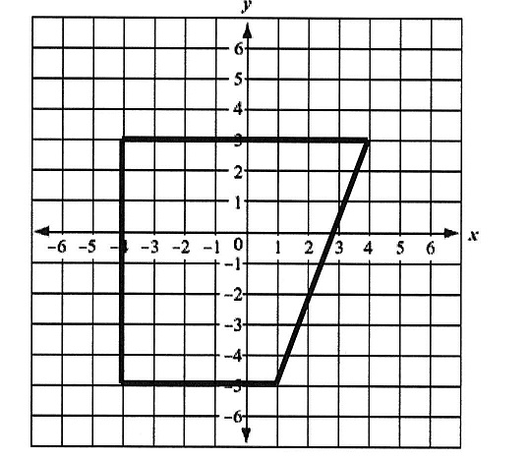The following graphed figure is:
4. square
5. trapezoid
6. rhombus
7. rectangle
8. A certain geometric figure has vertices with the coordinates (1, -1), (2, -3), (-4, -3), and (-3, -1). On the grid below, draw this geometric figure. What is the name of the geometric figure? Justify your answer.

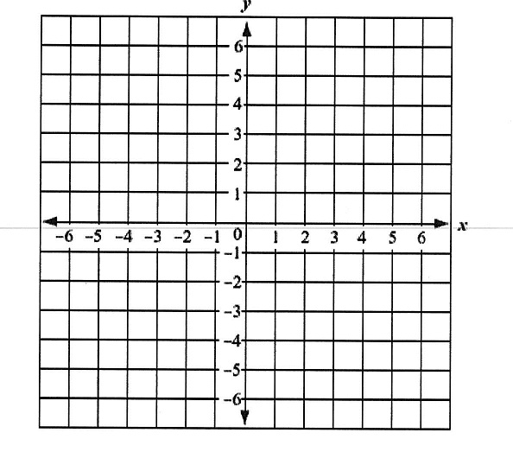

________________________________________________________________________________________________________________________________________________________________________________________________________________________________________________________________________________________________________________________

1. The following figure has how many lines of symmetry?
2. 0
3. 1
4. 2
5. 3