Mathematics

Power Standard 7:11 an d 7:12

Pretest

Name __________________________________________________________ Hour __________

1. If the diameter of a circle is doubled, what will happen to the circle’s radius?
2. It will not change.
3. It will be cut in half.
4. It will also double.
5. It cannot be determined.
6. Purdue University’s marching band has a drum with a diameter of 8 feet. What is its circumference to the nearest tenth? Use 3.14 for $π$.
7. Find the area of a circle with a diameter of 11.6 centimeteres. Round to the nearest tenth and use 3.14 for $π$.
8. Find the surface area of the rectangular prism with a length of 6 cm, a width of 17 cm, and a height of 19 cm.
9. Find the volume of the rectangular prism below.

12 cm

4 cm

3 cm

1. Find the surface area of the triangular prism below. (Hint: The height of the triangle is 3.5 m)

4 m

4 m

11 m

4 m

1. Find the volume of the triangular prism below.

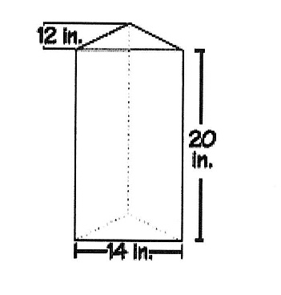

1. A cylinder has a radius of 8 inches and a height of 12 inches. What is the surface area of this cylinder? Use 3.14 for $π$. Round to the nearest tenth, if necessary.
2. Find the volume of the cylinder below. Use 3.14 for $π$. Round to the nearest tenth, if necessary.

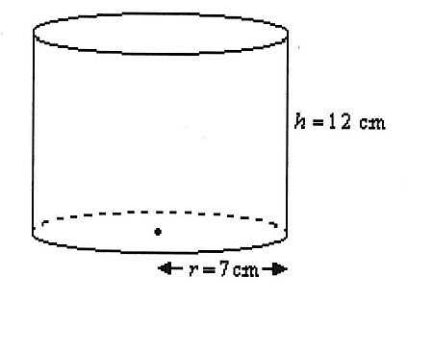

1. 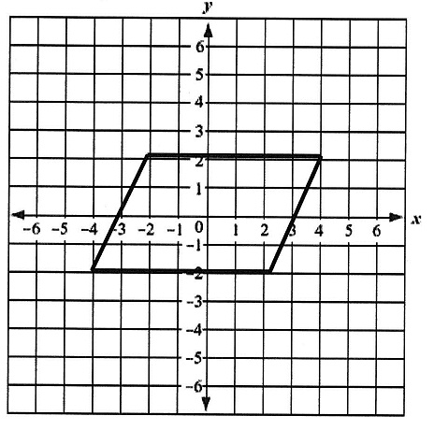The following graphed figure is a:

1. trapezoid
2. rectangle
3. rhombus
4. parallelogram
5. On the coordinate plane shown below, draw a rectangle with its vertices at the points

(2, -2), (8, -2), 8, 8), (2, 8). What is the area, in square units, of this rectangle?

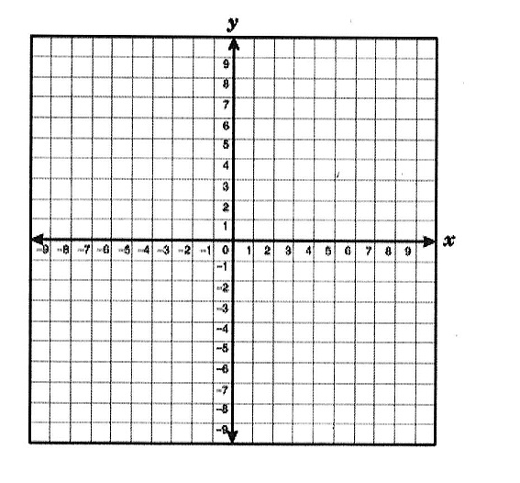

1. The following figure has how many lines of symmetry?
2. 0
3. 1
4. 2
5. 3