Easy Classroom Websites with Posterous

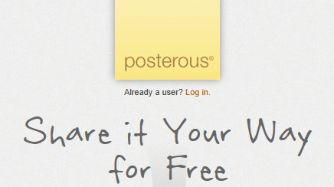

Many people have asked me for help setting up a new blog or web page. In the past, there have been several options, including one hosted using TigerMail, WordPress, Blogger, or even Google Sites through our media accounts. These options are all fine, but there is an easier, faster, and I think much better option out there. It's called Posterous.
The best thing about Posterous is that you compose new posts in your email! If you can send an email, you can make a new post on a Posterous blog. All you need to do is register your email address, then compose an email to post@posterous.com using that email address. Just moments after you send, Posterous will update you blog. It's that simple! You can even attach pictures or other files, and make them available on your blog.

1. Go to https://posterous.com/
2. In the yellow field, enter your email address, pick a username and password, and click the "Let's go!" button.
3. Check your email. You should recieve a message from Posterous asking you to confirm your email address. Do so.
4. That's it! You will be taken to a page where you can adjust your settings if you like.
5. Test your new Posterous blog by sending an email to post@posterous.com. The subject line will be the title, and the body of the email is the actual blog post.
6. You can attach pictures, documents, etc. just like you would when sending to anyone else, and they will appear on your blog.
7. After you send your email, within a few minutes you should get another email confirming your post!

A few things to keep in mind. Posterous is very easy to use, but can appear rather plain unless you customize it a bit. You can link Posterous to your existing Blogger or WordPress site very easily. Remember that your Posterous blog's web address ishttp://yourusername.posterous.com when you share it. If you need more help, please let me know! Enjoy posting with no hassles or trouble at Posterous!

