Communication Arts
Power Standard 8:5
Pre-Formative
Name ____________________________________________ Hour ____________

DIRECTIONS: Read “The Odd Olympics of 1904”. Then answer questions 1 & 2.
- Which of the following sentences best summarizes the passage?
- There were cheaters in the 1904 Olympics.
- The 1904 Olympics were unimpressive.
- Chicago and St. Louis battled to host the 1904 Olympics.
- The current Olympic medal system originated in 1904.

- Four runners from the 1904 Olympics are mentioned in the passage. What do the runners have in common?
- All of the runners contributed to the oddness of the 1904 Olympics.
- All of the runners cheated to try to win the 1904 Olympic marathon.
- All of the runners represented foreign countries in the 1904 Olympics.
- All of the runners had a desire to win the 1904 Olympic marathon.

DIRECTIONS: Read “Art Built on Sand”. Then answer questions 3 – 5.

Use this graphic organizer for questions 3 & 4.
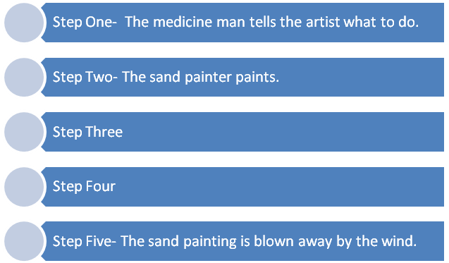
- Which of the following best completes step three in the graphic organizer above?
- The sand artist sprinkles sand onto the ground.
- The sand artist has to re-paint the painting.
- The elders sit in a circle and sing.
- The medicine man blesses the painting.

- Which of the following best completes step four in the graphic organizer above?
- The sun sets on the sacred sand painting.
- The artist makes straight lines and perfect angles.
- Balance is restored between good and evil.
- Tourists buy a non-sacred sand painting.

- Tell how Navajo sand painters solve the problem of not wanting their permanent sand paintings to have sacred power. Use two detail/examples from the passage to explain who this course of action is effective.
________________________________________________________________________________________________________________________________________________________________________________________________________________________________________________________________________________________________________________________________________________________________________________________________________________________________________________________________________________________________________________________________________________________________________________________________________________________________________________________________________________________________________________________________________________________________________________________________________________________________________________________________________________________________________________________________________________________________________

