Communication Arts

Power Standard 7.6

Formative Test

Name _______________________________________________________________ Hour _____

**DIRECTIONS:** Read the poem “The Eagle” by Alfred Lord Tennyson and answer the questions that follow.

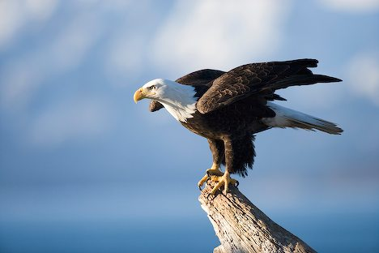

**The Eagle**

1*He clasps the crag with hooked hands;*2*Close to the sun in lonely lands,*3*Ring’d with the azure world, he stands.*

4*The wrinkled sea beneath him crawls;*5*He watches from his mountain walls,*6*And like a thunderbolt he falls.*

1. Which line from the poem contains alliteration?
2. Line 6
3. Line 4
4. Line 3
5. Line 1
6. Write a line from the poem that is an example of personification. Explain why it is personification.

________________________________________________________________________________________________________________________________________________________________________________________________________________________________________________________________________________________________________________________________________________________________________________________________________________________________________________________________________________________________________________________________________________________________________________________________________________________________________________________________________

**DIRECTIONS:** Read the following excerpt from E.B. White’s “Dog Around the Block” and answer the question that follows.

*Dog around the block, sniff,  
Hydrant sniffing, corner, grating,  
Sniffing, always, starting forward,  
Backward, dragging, sniffing backward,  
Leash at taut, leash at dangle,  
Leash in people’s feet entangle--*

1. Which of the following literary devices is used most often in the poem?
2. simile
3. metaphor
4. onomatopoeia
5. hyperbole

**DIRECTIONS:** Read the following passage and answer the question.

My brain was ready to explode. My teachers had given me a million homework assignments. And even more hard tests. There was no way I was ever going to get them all done. My parents were going to kill me when they saw my report card.

1. Which of the following literary devices is used most often in the passage above?
2. simile
3. metaphor
4. onomatopoeia
5. hyperbole

**DIRECTIONS:** Read the following passage from “Exploring the Titanic”, a nonfiction story by Robert D. Ballard, and answer questions 5 and 6.

In 1907, nearly ten years after *The Wreck of the Titan* was written, two men began making plans to build a real Titanic ship. At a London dinner party, as they relaxed over coffee and cigars, J. Bruce Ismay, president of the White Star Line of passenger ships, and Lord Pirrie, chairman of Harland & Wolff Shipbuilders, discussed the plan to build three enormous ocean liners. Their goal was to give the White Star Line a competitive edge in the Atlantic passenger trade with several gigantic ships whose accommodations would be the last word in comfort and elegance.  
 The two men certainly dreamed on a grand scale. When these floating palaces were finally built, they were so much bigger than other ships that new docks had to be built on each side of the Atlantic to service them. Four years after that London dinner party, the first of these huge liners, the *Olympic*, safely completed her maiden voyage.  
 On May 31, 1911, the hull of the *Titanic* was launched at the Harland & Wolff shipyards in Belfast, Ireland before a cheering crowd of 100,000. Bands played, and people came from miles around to see this great wonder of the sea . . .

1. Which one of the following literary devices is in this line from the second paragraph?

When these floating palaces were finally built, they were so much bigger than other ships . . .

1. simile
2. metaphor
3. onomatopoeia
4. hyperbole
5. Is the underlined passage in the last paragraph an example of hyperbole? Explain **WHY** or **WHY NOT**.

________________________________________________________________________________________________________________________________________________________________________________________________________________________________________________________________________________________________________________________________________________________________________________________________________________________________________________________________________________________________________________________________________________________________________________________________