Mathematics

Power Standard 8:8

Summative Test

Name ______________________________________ Hour _________

[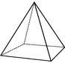](http://www.wqsb.qc.ca/philemon/pmessier/images/Square_pyramid.gi)

1. Identify the figure above. Identify number of faces, vertices, and edges.

Name of figure ________________

# of faces ___________

# of vertices __________

# of edges __________

1. Explain the difference in a prism and a pyramid.
2. Draw a mat plan for the 3-D figure below.

Then draw the front view, side view, and top view.

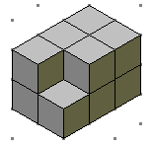

Mat plan:

Front view:

Side view:

Top view:

1. Use the mat plan below to draw a 3-D figure on isometric dot paper.

4 3 2 2

1 1 1

Isometric dot paper at: http://illuminations.nctm.org/Lessons/Isometric/Isometric-AS-DotPaper.pdf