Mathematics

Power Standard 8:8

Post-Formative Test

Name ____________________________________________ Hour ____________

[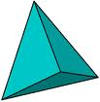](http://www.sydneyr.det.nsw.edu.au/support/curriculum/ict/gymeabay07/clip_image001_057.gif)

1. Identify the figure above. Identify number of faces, vertices, and edges.

Name of figure:_________________

# of faces _____________

# of vertices ______________

# of edges ___________

1. Does a pyramid ever have parallel sides? Explain your reasoning.
2. Draw a mat plan for the 3-D figure below.

Then draw the front view, side view, and top view.

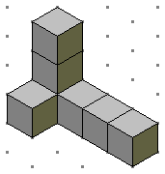

front

side

Mat plan:

Front view:

Side view:

Top view:

1. Use the mat plan below to draw a 3-D figure on isometric dot paper.

1

1

2

3

1

1

2

1

1

1

