Communication Arts

Power Standards 8:1 & 8:2

Post-Formative Test

Name _____________________________________________________________________ Hour ___________

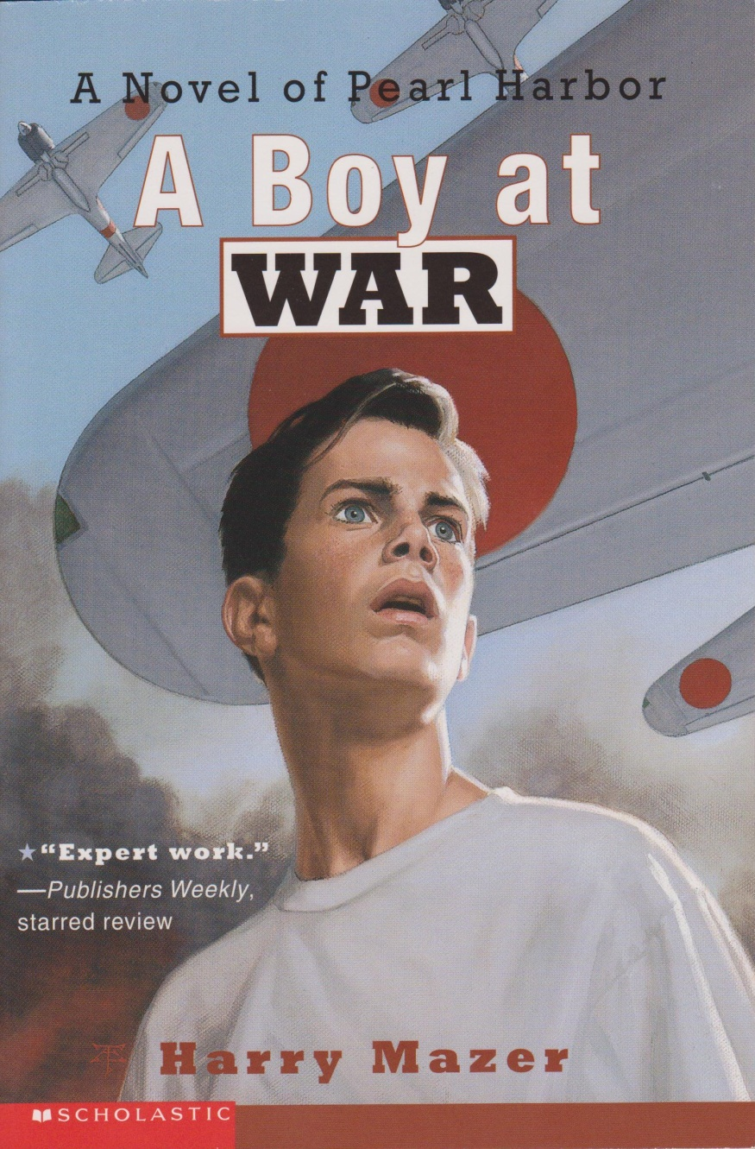

1. Based on the title and illustration, predict what you think the novel will be about. Provide **two** details from the novel cover to support your answer.

____________________________

____________________________

____________________________

____________________________

___________________________

____________________________

____________________________

____________________________

____________________________

____________________________

____________________________

____________________________

1. Using your knowledge of root words and affixes, break apart and explain the meaning of the word ***impossible****.*

____________________________________________________________________________________________________________________________________________________________________________________________________________________________________________________________________________________________________________________

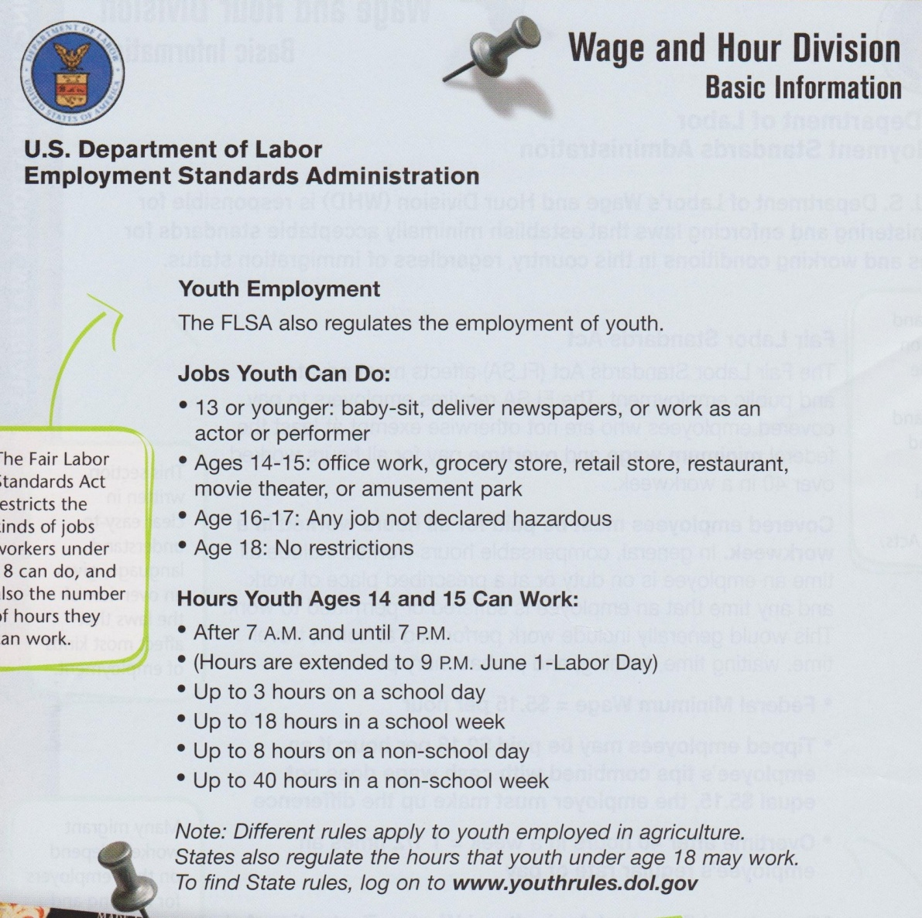

1. Why is the information in the above passage written with subheadings and bullet points instead of paragraphs? Explain your reasoning using **one** detail from the passage to support your answer.

________________________________________________________________________________________________________________________________________________________________________________________________________________________________________________________________________________________________________________________________________________________________________

________________________________________________________________________________________________________________________

**Read the excerpt from the play, *The Diary of Anne Frank* and answer the question.**

**ANNE**: [*Pulling out a pasteboard-bound book*]A diary! [*She throws her arms around her father.*]I’ve never had a diary. And I’ve always longed for one. [*She looks around the room.*]Pencil, pencil, pencil, pencil. [*She starts down the stairs.*] I’m going down to the office to get a pencil.

**Mr. Frank:** Anne! No! [*He goes after her, catching her by the arm and pulling her back.*]

1. Explain the purpose of the italicized writing within the brackets.

___________________________________________________________________________________________________________________________________________________________________________________________________________________________________________________________________________________________________________________________________________________________________________________________________________________________________________________________________________________________________________________________________________________________

1. What is the meaning of the prefix ***em-?***
2. in
3. not
4. cause to
5. across
6. What is the meaning of the suffix **-*itive***?
7. state of
8. adjective form of a noun
9. process
10. possessing the qualities of

**Read the following passage and answer the question below.**

**Firewood**

There are three types of firewood. Any twig narrower than your pinkie is known as tinder. These pieces are used to start a fire because they light easily. But because they are so small, they also burn quickly.

Sticks that are thicker than your pinkie but narrower than your thumb are called kindling. Kindling is useful once the campfire has gained strength but is still not strong enough to cook food, roast marshmallows, or provide steady light. Kindling takes longer to catch fire, but it burns longer than tinder does.

Once your campfire is going strong, you can add fuel, or sticks that are wider than your thumb. Fuel will **sustain** your fire for a long time. This will allow you to sit back, relax, and enjoy your campfire.

1. In the last paragraph, what does the word ***sustain*** mean?
2. to harm
3. to grow out of control
4. to support or nourish
5. to ignore
6. In a science book, which of the following is a likely place to find the definition of a boldface word?
7. index
8. chart
9. table of contents
10. margin note
11. Which of the following lists of the words is correctly alphabetized?
12. idiom, icicle, italics
13. cat, cry, cut
14. lake, love, liar
15. bird, basket, blunder
16. The word ***gift*** would appear between which of the following guide words?
17. glide-glisten
18. guilt-gully
19. geyser-girl
20. grand-great

11. On your “Summer Reflection” essay your teacher commented that you used the word ***bored*** five times. She asks you to revise it and turn it in again. What tool do you use to find better word choices?

1. language textbook
2. online Encyclopedia
3. reference book about the seasons
4. thesaurus

**Use the following dictionary entry to answer the question below.**

**Dictionary Entry**

**scope** *n* **1:** the range of one’s perceptions, thoughts, or actions **2:** breadth or opportunity to function

**3:** the area covered by a given activity or subject **4:** the length or sweep of a mooring cable **5:**  a viewing instrument such as a microscope, periscope, or telescope

Read the following passage.

**Havasupai- People of the Blue-Green Waters**

Imagine you are a member of an ancient tribe that settled a thousand years ago in a canyon that was grand beyond human scope. Your world is a paradise: desert crags of colorful sandstone, majestic waterfalls, the mighty Colorado River, and the many streams that flow into the river. Your people are nomads who spend their springs and summers in the canyon, growing corn, beans, and squash. In the fall, you leave the canyons for the southern plateaus, where you hunt the deer, longhorn sheep, and long-eared rabbits of the Southwestern desert.

1. Use the dictionary entry to determine the best meaning for the word *scope* as used in the

passage?

1. meaning 1
2. meaning 3
3. meaning 4
4. meaning 5