MPS7:8Summative Scoring Guide

ITEM# | SR | CR | PT | GLE | OBJ | EXP | DESCRIPTOR
1. | A |  | 1

ITEM# | SR | CR | PT | GLE | OBJ | EXP | DESCRIPTOR
2. | B |  | 1

ITEM# | SR | CR | PT | GLE | OBJ | EXP | DESCRIPTOR
3. |  | X | 3
Answer: Sample Answer:
Types of Movies
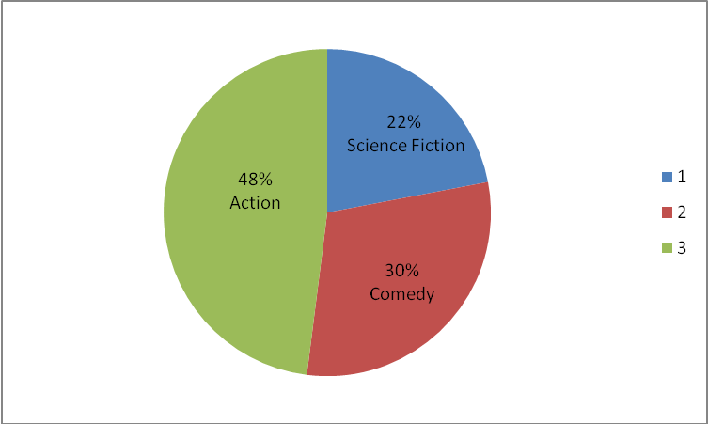

Key Elements: Graph is titled; sections on circle graph are correct size (degrees); sections on circle graph have labels with category and percent

3 points: Graph contains all 3 key elements.
2 points: Graph contains 2 key elements.
1 point: Graph contains 1 key element.
O points: Graph contains no key elements.
ITEM# | SR | CR | PT | GLE | OBJ | EXP | DESCRIPTOR
4. | B |  | 1
ITEM# | SR | CR | PT | GLE | OBJ | EXP | DESCRIPTOR
5. |  | X | 4
Answer: 37.5; 34; 56; 37
4 points: Exemplary response; all 4 measures correctly given
3 points: 3 measures correctly given
2 points: 2 measures correctly given
1 point: 1 measure correctly given
0 points: no measures correctly given
ITEM# | SR | CR | PT | GLE | OBJ | EXP | DESCRIPTOR
6. |  | X | 2
Answer: 26 students
2 points: Exemplary response; correct answer and work given
1 point: Correct answer OR correct work given
0 points: Neither correct answer nor correct work given
ITEM# | SR | CR | PT | GLE | OBJ | EXP | DESCRIPTOR
7. | D |  | 1

