MPS7:4 Post-Formative Scoring Guide
ITEM# | SR | CR | PT | GLE | OBJ | EXP | DESCRIPTOR
1. | A |  | 1 | A1B | 1 | A | Identify arithmetic and geometric sequences

ITEM# | SR | CR | PT | GLE | OBJ | EXP | DESCRIPTOR
2. | D |  | 1 | A3A | 3 | A | Identify various representations for the same equations

ITEM# | SR | CR | PT | GLE | OBJ | EXP | DESCRIPTOR
3. | B |  | 1 | A1B, A1D, A4A | 2 | B | Determine if a set of ordered pairs represents a function

ITEM# | SR | CR | PT | GLE | OBJ | EXP | DESCRIPTOR
4. | c |  | 1 | A1B | 1 | A | Identify arithmetic and geometric sequences

ITEM# | SR | CR | PT | GLE | OBJ | EXP | DESCRIPTOR
5. | C |  | 1 | A1B, A1D, A4A | 2 | C | Classify functions as linear or non-linear by determining constant rate of change

ITEM# | SR | CR | PT | GLE | OBJ | EXP | DESCRIPTOR
6. |  | X | 2 | A1B, A1D, A4A | 2 | A | Identify domain and range
Answer: {-2, 1, 4, 7, 10}
2 points: All five domains of the ordered pairs are given
1 point: Some domains of the ordered pairs are given
0 points: No correct domains for the ordered pairs are given

ITEM# | SR | CR | PT | GLE | OBJ | EXP | DESCRIPTOR
7. |  | X | 2 | A3A | 3 | B | Create various representations of the same equation (write equation from graph)
Answer: Various student answers. Example below.
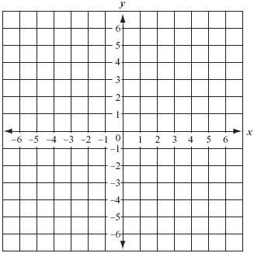
2 points: correct line for equation graphed passing through correct ordered pairs
1 point: line passes through some correct ordered pairs
O point: line does not pass through any correct ordered pairs

ITEM# | SR | CR | PT | GLE | OBJ | EXP | DESCRIPTOR
8. |  | X | 2 | A1B | 1 | B | State the pattern rule and extend patterns
Answer: add 0.8; 5.6, 6.4, 7.2
2 points: Exemplary response; both rule and next three terms correct
1 point: Either rule or next three terms correct, but not both
0 points: Neither rule nor next three terms correct

ITEM# | SR | CR | PT | GLE | OBJ | EXP | DESCRIPTOR
9. |  | X | 2 | A1B | 1 | C | Find the nth term of a given sequence
Answer: 1,400
2 points: Exemplary response; correct process for finding 100th term is shown and correct 100th value is given
1 point: correct process for finding 100th term is shown OR correct 100th value is given
0 points: Neither correct process for finding 100th term is shown nor correct 100th value is given

