Mathematics
Power Standards 7:2
Post-Formative Test
Name _________________________________________________________ Hour ___________

- Which of the following is the correct comparison of 75% and .71?
- 75 % < .71
- .71 ≤ 75 %
- .71 ≥ 75%
- 75% = .71

- Between which two integers would -12.095 be placed on a number line?
- -9 and -10
- -10 and -11
- -11 and -12
- -12 and -13

- Which of the following problem(s) would have a negative answer?
- -35 – 5
- -10 – (-11)
- -64 ÷ -8
- -13 + 25

- Which of the following correctly orders the rational numbers from greatest to least?
- -2.18, -2.6, -2.05, -1.1, -1.84
- .25, .28, .3, .38, .44
- 6.72, 6.01, 4.02, 3.97, 3.67
- -1.040, -11.04, -11.3, -10.04, -10.4

- Which of the following is NOT a correct step when subtracting integers?
- You must change the subtraction sign to a plus sign.
- You change the sign of both integers.
- You change the sign of the second integer.
- You leave the first integer alone.

- For which problem must you use absolute value in order to solve?
- -18 ÷ -3
- -14 + -15
- 13 + -25
- -6 · 2
- Which of the following is equivalent to -20 -13?
- 20 + (-13)
- -20 + (-13)
- -20 + 13
- None of the above
- The low temperature on Monday was 6 degrees warmer than Sunday’s low of -12°F.
The low temperature on Tuesday was 4 degrees warmer than Monday’s low. What
was the low temperature on Tuesday?
Show your work here.

Answer______________

- A cooler holds 320 ounces of water. Michelle uses the cooler to fill 12 eight-ounce cups of water, and then fills a 36-ounce pitcher. How much water is left in the cooler?
Show your work here.

Answer______________

- When multiplying or dividing an even amount of negative numbers will your answer always be positive? Explain why or why not.
__________________________________________________________________________________________________________________________________________________________________________________________________________________________________________________________________________________________________________________________________________________________________________________________________________________________________________________________________________________________________________________________________________________________________
Use the coordinate plane below to graph and label the ordered pairs for questions 11-14.

- A (-6, -5)
- B (3, 2)
- C (0, -7)
- D(-4, 3)

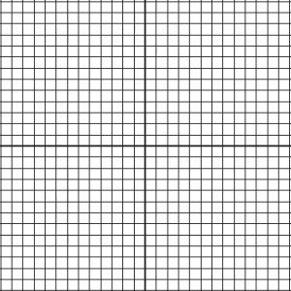
Write the ordered pair for each point graphed at the right. Then name quadrant or axis on which each point is located.

- E
- F

E
F

