Mathematics

Power Standard 7:11

Summative Test

Name __________________________________________________________ Hour __________

1. Which of the following correctly describes the relationship between the radius and diameter of a circle?
2. The diameter is half the radius.
3. It takes two radii to equal a diameter.
4. The radius is twice the diameter.
5. It takes two diameters to equal one radius.
6. A mysterious crop circle was found in England. It was created in a single night by an unknown source and had a diameter of 250 ft. What is the circumference of the circle?
7. A CD has a diameter of 12 centimeters. The hole in the middle of the CD has a diameter of 1.5 centimeters. Find the area of one side of the CD to the nearest tenth. Use 3.143 for $π$.
8. Find the surface area of the rectangular prism below.

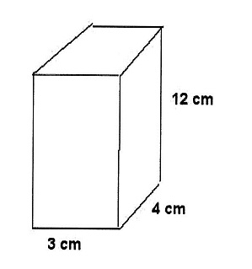

1. Find the surface area of the triangular prism below. (Hint: the length of *a* is 5 units*.)*

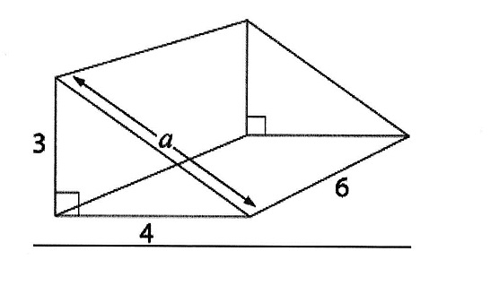

1. 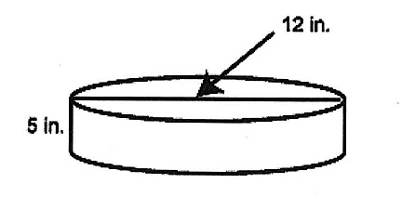Find the surface area of the cylinder below. Use 3.14 for $π$. Round to the nearest tenth, if necessary.