Mathematics

Power Standard 7:11

Formative Test

Name __________________________________________________________ Hour __________

1. What is the diameter of a circle if the radius is 14 m?
2. 28 m
3. 7 m
4. 88 m
5. 14 m
6. A hamster’s running wheel has a radius of 3 in. What is the running wheel’s circumference rounding to the nearest tenth? Use 3.14 for $π$.
7. Find the area of the face of a Sacagawea $1 coin if the diameter is 26.5 millimeters. Round to the nearest tenth and use 3.14 for $π$.
8. Find the surface area of the rectangular prism with a length of 5 ft, a width of 3 ft, and a height of 9 ft.
9. Find the surface area of the triangular prism below.

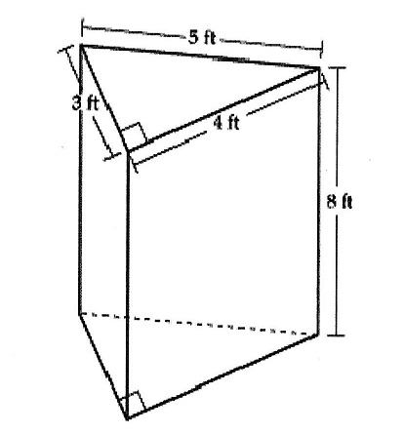

**Note: The figure is not drawn to scale.**

1. Find the surface area of the cylinder below. Use 3.14 for $π$. Round to the nearest tenth, if necessary.

