Communication Arts

Power Standard 7:1 & 7:2

Summative Test

Name ____________________________________________________________________ Hour __________

**Read the poem and answer the question below.**

As for me,

I have learned

to worship

the sun

90

again.

To affirm3

the adventures

of hair.

For we are all

95

*Splendid*

descendants

of Wilderness

Eden:

needing only

100

to see

each other

without

commercials

to believe.

105

Copied skillfully

as Adam.

O*riginal*

as Eve.

**_______________________________**

**3. affirm:** to declare positively; support

1. Why did the author use a footnote in this poem?

________________________________________________________________________________________________________________________________________________________________________________________________________________________________________________________________________________________________________________________________________________________________________________________________________________________________________________________________________________________________________________________

**The Smallest Dragon Boy**

2. Look at the title and illustration on the right.

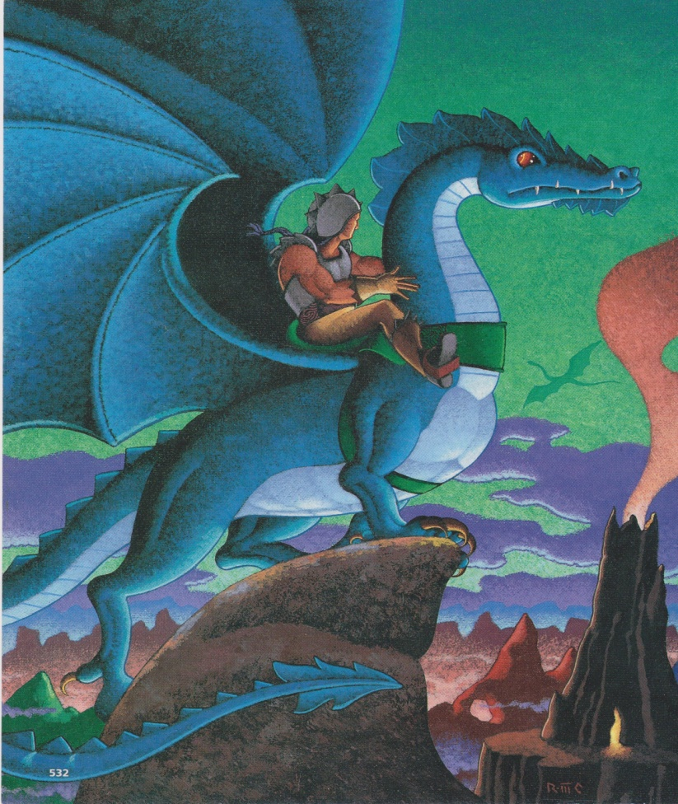 Predict what the short story will be about.

Provide **two** details to support your answer.

____________________________________

____________________________________

____________________________________

____________________________________

____________________________________

____________________________________

____________________________________

____________________________________

____________________________________

____________________________________

____________________________________

____________________________________

____________________________________

**Read the following passage and answer the question below.**

**First Aid for a Snake Bite**

Follow these guidelines to care for someone bitten by a snake:

* Call 9 -1-1 or the local emergency number.
* Wash the wound, if possible.
* Immobilize the affected part.
* Keep the affected area lower than the heart, if possible.
* Minimize the victim’s movement. If possible, carry a victim who must be transported or have him or her walk slowly.
* Do not apply ice.
* Do not cut the wound.
* Do not apply a tourniquet.
* Do not use electric shock

3. Explain why you think the author chose to make a bulleted list instead of writing paragraphs. Use

information from the text to support your answer.

____________________________________________________________________________________________________________________________________________________________________________________________________________________________________________________________________________________________________________________________________________________________

_______________________________________________________________________________________

4. Using your knowledge of root words and affixes, break apart and explain the meaning of the word

***defrost****.*

____________________________________________________________________________________________________________________________________________________________________________________________________________________________________________________________________________________________________________________________________________________________________________________________________________________________________

5. How are plays different from short stories?

1. Plays have character lists; short stories do not.
2. Plays have dialogue; short stories do not.
3. Plays have conflict; short stories do not.
4. Plays have a setting; short stories do not.

6. Which prefix would you add to the root word ***father*** to make a new word that means ***a father who***

***came before****?*

1. de-
2. semi-
3. fore-
4. mis-

7. Which suffix would you add to the root word ***wood*** to make a new word that means ***made of***

***wood***?

1. -ial
2. -en
3. -able
4. -ible

**Read the following sentence and answer the question below.**

George dropped a smoking match in the forest, and the next day, there was a **conflagration.**

1. What is the meaning of the word ***conflagration*** as it is used in the sentence*?*
2. a disastrous fire
3. a group of flags
4. a church meeting
5. a harsh warning

He came into the room to shut the windows while we were still in bed, and I saw he looked ill. He was shivering, his face was white, and he walked slowly as though it ached to move.

“What’s the matter, Schatz1?”

“I’ve got a headache.”

“You better go to bed.”

“No. I’m all right.”

“You go to bed. I’ll see you when I’m dressed.”

But when I came downstairs he was dressed, sitting by the fire, looking a very sick and miserable boy of nine years. When I put my hand on his forehead, I knew he had a fever.

“You go to bed,” I said. “You’re sick.”

“I’m all right,” he said.

When the doctor came, he took the boy’s temperature.

“What is it?” I asked him.

“One hundred and two.”

1. **Schatz** (shäts) German term of affection, used here as a loving nickname

9. What is the meaning of the word

*Schatz* as it is used in the passage

on the right?

A. a loving nickname

B. a playful pet dog

C. a kind German

D. a high fever

1. Which of the following groups of words are correctly alphabetized?
2. sod, salary, sudden
3. frog, fat, former
4. pattern, pitch, pollution
5. diary, dear, dart

11. Which of the following words would be on a dictionary page with the guide words ***acrobat-addict***?

1. acrimonious
2. action
3. addition
4. attitude

12. Your teacher returns an essay you have written. Her comment is that you have used the word

***awesome*** too many times in your writing. As you revise your writing, which tool will be useful in

helping to find other words that have the same meaning as ***awesome***?

1. dictionary
2. index
3. glossary
4. thesaurus

**Read the dictionary entry and answer the question below.**

**drove:** v. **1:** past tense of drive, n. **2.** A flock or herd being driven in a body, **3:** a large mass of people moving or acting as a body, **4:** a stone mason’s broad edged chisel

1. In the following sentence, which meaning would be most correct?

He used the **drove** to create a beautiful marble statue.

1. meaning 1
2. meaning 2
3. meaning 3
4. meaning 4