Mathematics

Power Standard 8:8 & 8:9 Combined

Summative Test

Name _______________________________________________ Hour _________

1. 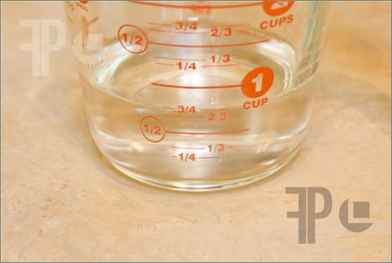 The precision of the measuring cup is:
2. 1 cup
3. $\frac{1}{4}$ cup
4. $\frac{1}{2}$ cup
5. $\frac{3}{4}$ cup
6. Determine the number of significant digits in the following number: 301.01

Number of significant digits: _______________

1. Compute using significant digits. Show work.

What is the area of a rectangle with a length of 17.25 mm and a width of 5.065 mm?

Area = ______________________________

1. Translate into an algebraic expression. The product of nine and two, increased by six.

A. ($\frac{9}{2}$)+6

B. 9(2+6)

C. (9·2)+6

D. (9+6)·(2+6)

1. Solve for x: 0.32x+0.07=0.55

A. 0.1984

B. 0.1536

C. 1.9375

D. 1.5

1. Kim got 22 out of 24 correct on her math test. Express the number she got

correct as a fraction in simplest form, as a decimal, and as a percent.

1. Draw a visual model to represent the following problem. Write and solve an equation that could be used to solve the problem.

The three sides of a triangle are x, x+3, and 2x+4. The perimeter of the triangle is 27 inches. Find the measure of all three sides.

1. What two consecutive integers have a sum of 39? Write and solve an equation that can be used to solve this problem.
2. Solve: show work

100x + -89x = 121