Mathematics

Power Standard 8:8

Pretest

Name ____________________________________________________ Hour ________

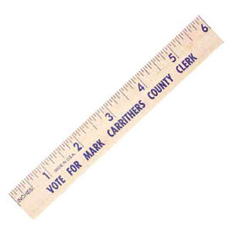

1. The precision of this ruler is:
2. $\frac{1}{16}$ inch
3. inch
4. cm
5. 6
6. Determine the number of significant digits in the following number: 1.234

Number of significant digits: __________________

1. Compute using significant digits. Show work.

Find the perimeter of a rectangle with a length 10.255cm and a width

of 7.1 cm.

Perimeter = ___________________

