Mathematics

Power Standard 8:8 & 8:9

Pretest

Name ____________________________________________________ Hour ________

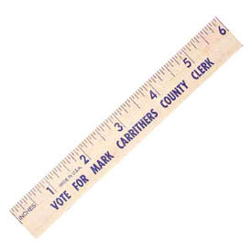

1. The precision of this ruler is:
2. $\frac{1}{16}$ inch
3. inch
4. cm
5. 6
6. Determine the number of significant digits in the following number: 1.234

Number of significant digits: __________________

1. Compute using significant digits. Show work.

Find the perimeter of a rectangle with a length 10.255cm and a width

of 7.1 cm.

Perimeter = ___________________

1. Translate into an algebraic expression. Six less than the product of nine and four.
2. 6-(9·4)
3. (9·4)-6
4. (6-9)·4
5. (9+4)-6
6. Solve for x: –($\frac{2}{3}$)x+6=2
7. 6
8. 6.666667
9. 5.7
10. 2.8
11. Rita got 12 out of 15 correct on her math test. Express the number she got correct as a fraction in simplest form, as a decimal, and as a percent.
12. Draw a visual model to represent the following problem. Write and solve an equation that could be used to solve the problem.

***The width of a rectangle is twice the length. The perimeter of the rectangle is 18”. What is the width and length of the rectangle?***

1. The sum of two consecutive integers is 27. What are the two integers? Write and solve an equation that can be used to solve this problem.
2. Solve: show steps

6x + -2 + 2x = -2 + 4x + 8

