Mathematics
Power Standard 8:8
Formative Test
Name ____________________________________________ Hour ____________
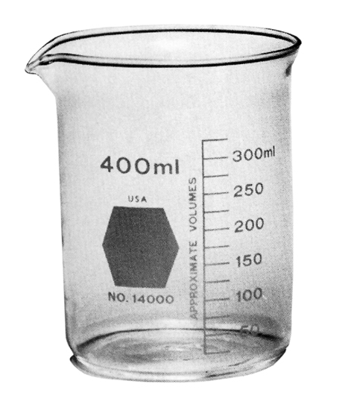

- The precision of the beaker on the right is:
- ml
- 400 ml
- 25 ml
- cups

- Determine the number of significant digits in the following number: 0.00421
Number of significant digits: ___________

- Compute using significant digits. Show work.
Find the perimeter of a triangle with sides of length 3.1 m, 12.02 m, and 7.223 m.
Perimeter = __________________

