Mathematics
Power Standard 8:8 & 8:9
Formative Test
Name ____________________________________________ Hour ____________
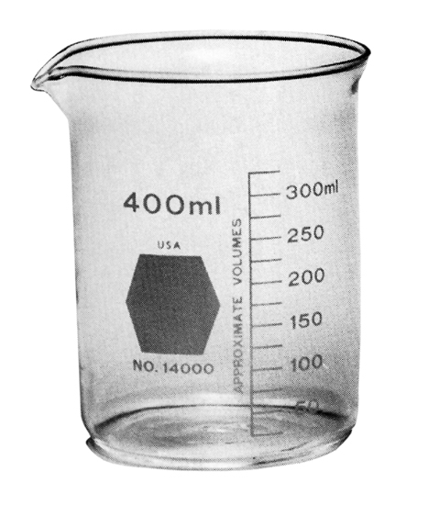

- The precision of the beaker on the right is:
- ml
- 400 ml
- 25 ml
- cups

- Determine the number of significant digits in the following number: 0.00421
Number of significant digits: ___________

- Compute using significant digits. Show work.
Find the perimeter of a triangle with sides of length 3.1 m, 12.02 m, and 7.223 m.
Perimeter = __________________

- Translate into an algebraic expression. Three more than the quotient of nine and three.
A. 3+()
B. 3+(9-3)
C. 3+()
D. 3·()

- Solve for x: 0.5x-5=15
A. 5
B. 20
C. 40
D. 10

- David got 12 out of 18 correct on his math test. Express the number he got correct as a fraction in simplest form, as a decimal, and as a percent.

- Draw a visual model to represent the following problem. Write and solve an equation that could be used to solve the problem.
The third side of an isosceles triangle is three times as long as each of the two equivalent sides. The perimeter of the triangle is 75 cm. Find the measure of all three sides.

- The sum of two consecutive integers is 9. What are the two integers? Write and solve an equation that can be used to solve this problem.

- Solve: Show steps.
-6 + 2x + 3x = 29

